**WEEK – 1**

**Aim :** Create a JDBC application which connects with an MS Access database and perform

CRUD Operations.

**Program :**

package javadbc;

import java.io.*;

import java.sql.*;

public class JavaDBC {

public static void main(String[] args)

{

try

{

Class.forName("net.ucanaccess.jdbc.UcanaccessDriver");

// E:\venkat sai\WebDev_Program\JDBC.accdb

Connection con = DriverManager.getConnection("jdbc:ucanaccess://E:\\venkat sai\\WebDev_Program\\JDBC.accdb");

Statement st = con.createStatement();

// Insert Query;

String sqlinsert = "insert into Employee values(68, 'A. Charan', 208456732, 95000)";

st.executeUpdate(sqlinsert);

// update Query

String sqlupdate = "update Employee set salary = 70000 where ID = 68";

//st.executeUpdate(sqlupdate);

// Delete record Query

String sqldelete = "delete from Employee where id = 4";

//st.executeUpdate(sqldelete);

// Create Query

String sqlcreate = "CREATE TABLE REGISTRATION " +

"(id INTEGER not NULL, " +

" first VARCHAR(255), " +

" last VARCHAR(255), " +

" age INTEGER, " +

" PRIMARY KEY ( id ))";

//st.executeUpdate(sqlcreate);

// Select Query

ResultSet rs = st.executeQuery("select * from Employee");

while(rs.next())

{

System.out.println("Employee ID Number is: " + rs.getInt(1));

System.out.println("Employee name is: " + rs.getString(2));

System.out.println("Employee Mobile Number : " + rs.getInt(3));

System.out.println("Employee Salary : " + rs.getInt(4));

System.out.println();

}

}

catch(Exception e)

{

System.out.println("An unknown Exception occured : \n\n" + e);

}

}

}

**Output :**

**Select Query**

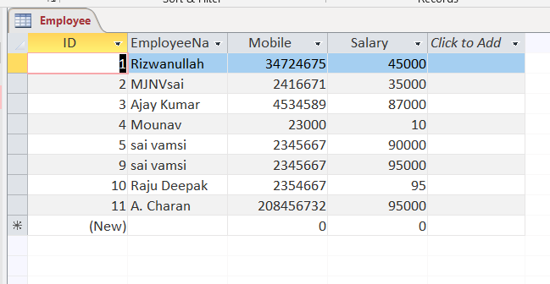

**Update Query**

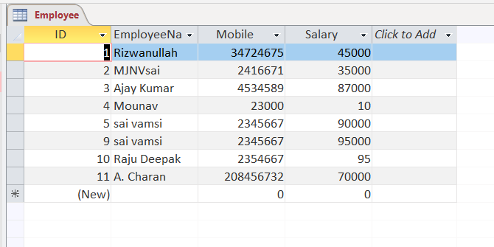

**Delete Query :**

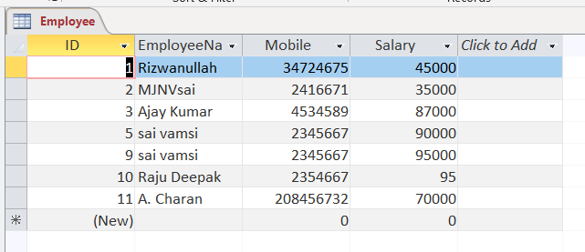

**Create Query :**

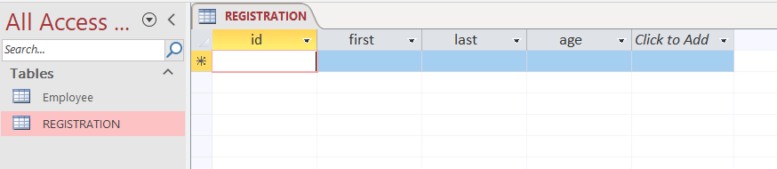

**Result :** Sucessfully Executed the Program.

**Week – 2**

**Aim :** Create a JDBC application which connects with an Mysql database and perform

CRUD Operations.

**Program :**

package javadbc;

import java.io.*;

import java.sql.*;

import java.util.*;

public class MySql

{

public static void main(String[] args)

{

try

{

Scanner s = new Scanner(System.in);

System.out.print("Enter Eno : ");

int a = s.nextInt();

System.out.print("Enter Ename : ");

String ss = s.next();

Class.forName("com.mysql.jdbc.Driver");

Connection con = DriverManager.getConnection("jdbc:mysql://localhost/it","root","");

Statement st = con.createStatement();

// Statement is an Interface and Connection is an Child Class

//Create Database

String sqldb = "create database 208W1A12A0";

//st.executeUpdate(sqldb);

//Create table

String sqltable = "create table employee (eno int, name varchar(20))";

//st.executeUpdate(sqltable);

// Insert Records

String sqlinsert = "insert into employee values(4,'kumar')";

//st.executeUpdate(sqlinsert);

String insertdynamic = "insert into employee values("+a+", '"+ss+"')";

//st.executeUpdate(insertdynamic);

// Update Query

String sqlupdate = "update employee set name='charan' where eno=268";

//st.executeUpdate(sqlupdate);

// Delete Query

String sqldelete = "delete from employee where eno=299";

//st.executeUpdate(sqldelete);

// Select Query

ResultSet rs = st.executeQuery("select * from employee");

while(rs.next())

System.out.println(rs.getInt(1) + " " + rs.getString(2));

con.close();

}

catch(Exception e)

{

System.out.println("An unknown Error occured : \n" + e);

}

}

}

**Output :**

**Create Query :**

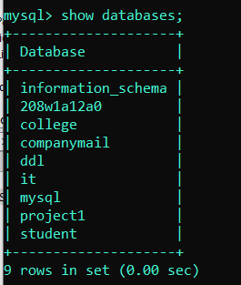

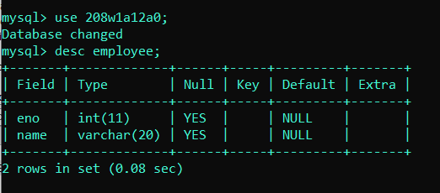

**Insert Query :**

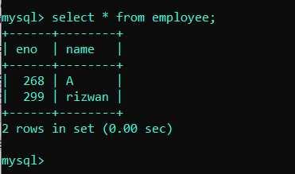

**Update Query :**

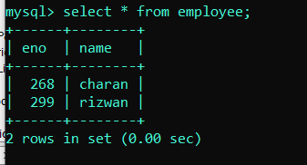

**Delete Query :**

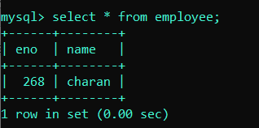

**Result :** Sucessfully Executed the Program.

**Week – 3**

**Aim :** Create a JDBC application and insert the records into Mysql database By using the

PreparedStatement interface.

**Program :**

package crudusingpreparedstatement;

import java.util.*;

import java.sql.*;

public class CRUDUsingPreparedStatement {

public static void main(String[] args) {

try {

// Scanner s = new Scanner(System.in);

// System.out.println("Enter values");

// int a = s.nextInt();

// String ss = s.next();

//for loading the driver, class is the base class (static method), to load the class dynamically into the program, to register the class with driver manager

Class.forName("com.mysql.jdbc.Driver");

//here student is database name, root is username and password

try (Connection con = DriverManager.getConnection("jdbc:mysql://localhost/student", "root", "")) {

//here sonoo is database name, root is username and password

Statement st = con.createStatement();

//int create=st.executeUpdate("create table employee (eno int, name varchar(20))");

int insert = st.executeUpdate("insert into details values('208w1a1299','rizwan','9.13')"); //static

// int insertdynamic = st.executeUpdate("insert into employee values(" + a + ",'" + ss + "')");//dynamic

// int update = st.executeUpdate("update employee set name='vrsec' where eno=4");

// int delete = st.executeUpdate("delete from details where roll='208w1a1299'");

// ResultSet rs = st.executeQuery("select * from details");

ResultSet rs;

//rs = st.executeQuery("select * from details");

String query = "select * from details where name=?";

PreparedStatement pstatement = con.prepareStatement(query);

pstatement.setString(1, "rizwan");

// pstatement.setString(2, "john doe");

// pstatement.setString(1, "9.00");

rs = pstatement.executeQuery();

while (rs.next()) {

System.out.println(rs.getString(1) + " " + rs.getString(2));

}

}

} catch (ClassNotFoundException | SQLException e) {

System.out.println(e);

}

}

}

**WEEK – 4**

**Aim :** Create a Login Web Application which interacts with an mysql database and validates

Login credentials of the user.

**Program :** index.html

<html>

<head>

<title> Just A login </title>

<meta charset="UTF-8">

<meta name="viewport" content="width=device-width, initial-scale=1.0">

</head>

<body>

<center>

<h1> <b> Login </b> </h1>

<form action = "Servlet1" method = "GET">

<label for = "dfu"> User Name : </label>

<input type = "text" name = "u1" /> <br> <br>

<label for = "dfp"> Password : </label>

<input type = "text" name = "u2" /> <br> <br>

<input type = "submit" value = "SUBMIT" />

</form>

</center>

</body>

</html>

**Program :** Servlet1.java

import javax.servlet.http.*;

import javax.servlet.*;

import java.io.*;

import java.sql.*;

public class Servlet1 extends HttpServlet

{

@Override

public void doGet(HttpServletRequest req,HttpServletResponse res) throws ServletException,IOException

{

res.setContentType("text/html");//setting the content type or mine type

PrintWriter pw = res.getWriter();//get the stream to write the data

//writing html in the stream

//pw.println("<html><body>");

String s1 = req.getParameter("u1");

String s2 = req.getParameter("u2");

boolean status = false;

try

{

Class.forName("com.mysql.jdbc.Driver");

Connection con = DriverManager.getConnection("jdbc:mysql://localhost/it", "root", "");

String checksql = "select * from login where user = ? and pass = ?";

PreparedStatement ps = con.prepareStatement(checksql);

ps.setString(1, s1);

ps.setString(2, s2);

ResultSet rs = ps.executeQuery();

while(rs.next())

{

status = true;

}

pw.print("<center> <h1> User Login Sucessfull </h1> </center>");

}

catch(Exception e)

{

e.printStackTrace();

}

}

}

.

**Week – 5**

**Aim :**  Create a Registration Web Application which interacts with Mysql database and

Save them into the Database.

**Program :** index.html

<html>

<head>

<title> Registration </title>

<meta charset="UTF-8">

<meta name="viewport" content="width=device-width, initial-scale=1.0">

</head>

<body>

<center>

<h1> <b> Registration Form </b> </h1>

<form action = "Servlet1" method = "GET">

<h3> Full Name : &nbsp; <input type = "text" name = "r1" /> </h3>

<h3> Email ID : &nbsp; <input type = "text" name = "r2" /> </h3>

<h3> Password : &nbsp; <input type = "password" name = "r3" /> </h3>

<h3> Gender : &nbsp; <input type = "radio" name = "r4" value = "male"/> Male &nbsp; <input type = "radio" name = "r4" value = "male"/> Female &nbsp; <input type = "radio" name = "r4" value = "male"/> Others </h3>

<h3> Date Of Birth : &nbsp; <input type = "date" name = "r5" /> </h3>

<h3> City : &nbsp; <input type = "text" name = "r6" /> </h3>

<h3> State : &nbsp; <input type = "text" name = "r7" /> </h3>

<h3> Country : &nbsp;

<select name = "r8">

<option> India </option>

<option> USA </option>

<option> Russia </option>

<option> Japan </option>

<option> Pakisthan </option>

<option> France </option>

<option> Germany </option>

</select>

</h3>

<h3> Mobile Number : &nbsp; <input type = "text" name = "r9" /> </h3>

<input type = "submit" value = "REGISTER" />

</form>

</center>

</body>

</html>

**Program :** Servlet1.java

import javax.servlet.http.*;

import javax.servlet.*;

import java.io.*;

import java.sql.*;

public class Servlet1 extends HttpServlet

{

@Override

public void doGet(HttpServletRequest req,HttpServletResponse res) throws ServletException,IOException

{

res.setContentType("text/html");//setting the content type or mine type

PrintWriter pw = res.getWriter();//get the stream to write the data

//writing html in the stream

//pw.println("<html><body>");

String s1 = req.getParameter("r1");

String s2 = req.getParameter("r2");

String s3 = req.getParameter("r3");

String s4 = req.getParameter("r4");

String s5 = (String)req.getParameter("r5");

String s6 = req.getParameter("r6");

String s7 = req.getParameter("r7");

String s8 = req.getParameter("r8");

String s9 = req.getParameter("r9");

boolean status = false;

try

{

Class.forName("com.mysql.jdbc.Driver");

Connection con = DriverManager.getConnection("jdbc:mysql://localhost/it", "root", "");

String checksql = "insert into register values(?, ?, ?, ?, ?, ?, ?, ?, ?)";

PreparedStatement ps = con.prepareStatement(checksql);

ps.setString(1, s1);

ps.setString(2, s2);

ps.setString(3, s3);

ps.setString(4, s4);

ps.setString(5, s5);

ps.setString(6, s6);

ps.setString(7, s7);

ps.setString(8, s8);

ps.setString(9, s9);

int result = ps.executeUpdate();

while(result > 0)

{

status = true;

}

pw.print("<center> <h1> Your Registration is Sucessfull !!! </h1> </center>");

}

catch(Exception e)

{

e.printStackTrace();

}

}

}

**Output :**

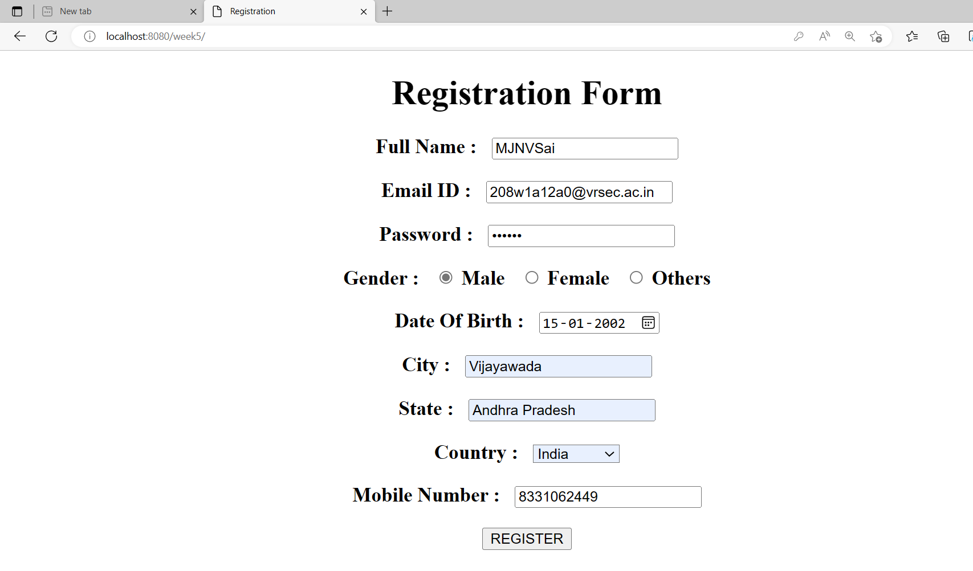

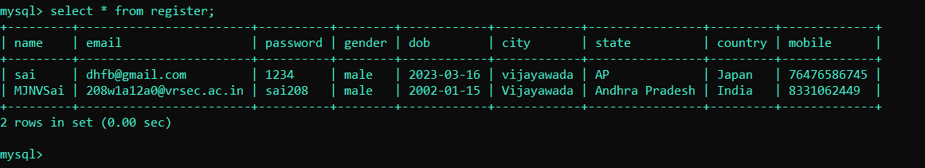

**Result :** Sucessfully Executed The Program.

**WEEK - 6**

**Aim :** Create a Web application in which user enters an Employee Number and

fetch the Employee Information and print it on servlet Page.

**Program :** Index.html

<html>

<head>

<title> Assignment 1 </title>

<meta charset="UTF-8">

<meta name="viewport" content="width=device-width, initial-scale=1.0">

</head>

<body>

<center>

<form action = "Servlet1" method = "GET">

<h1> <b> Employee Details </b> </h1>

<label for = "em"> Enter a Employee Number : </label>

<input type = "text" name = "id" /> <br> <br>

<input type = "submit" value = "SUBMIT" />

</form>

</center>

</body>

</html>

**Program :** Servlet1.java

import javax.servlet.http.*;

import javax.servlet.*;

import java.io.*;

import java.sql.*;

public class Servlet1 extends HttpServlet

{

@Override

public void doGet(HttpServletRequest req,HttpServletResponse res) throws ServletException,IOException

{

res.setContentType("text/html"); //setting the content type or mine type

PrintWriter pw=res.getWriter(); //get the stream to write the data

int id = Integer.parseInt(req.getParameter("id"));

try

{

Class.forName("com.mysql.jdbc.Driver");

Connection con = DriverManager.getConnection("jdbc:mysql://localhost/it", "root", "");

PreparedStatement ps = con.prepareStatement("select * from javaemployee where id = ?");

ps.setInt(1, id);

ResultSet rs = ps.executeQuery();

while(rs.next())

{

pw.println("<center>");

pw.println("<h1> Employeee Id : " + rs.getInt(1) + "</h1> <br> <br>");

pw.println("<h1> Employeee Name : " + rs.getString(2) + "</h1> <br> <br>");

pw.println("<h1> Employeee City : " + rs.getString(3) + "</h1> <br> <br>");

pw.println("<h1> Employeee Company : " + rs.getString(4) + "</h1> <br> <br>");

pw.println("<h1> Employeee Salary : " + rs.getFloat(5) + " Lakhs </h1> <br> <br>");

pw.println("</center>");

}

}

catch(Exception e)

{

pw.println("An unexcepted Error Occured");

}

}

}

**Output :**

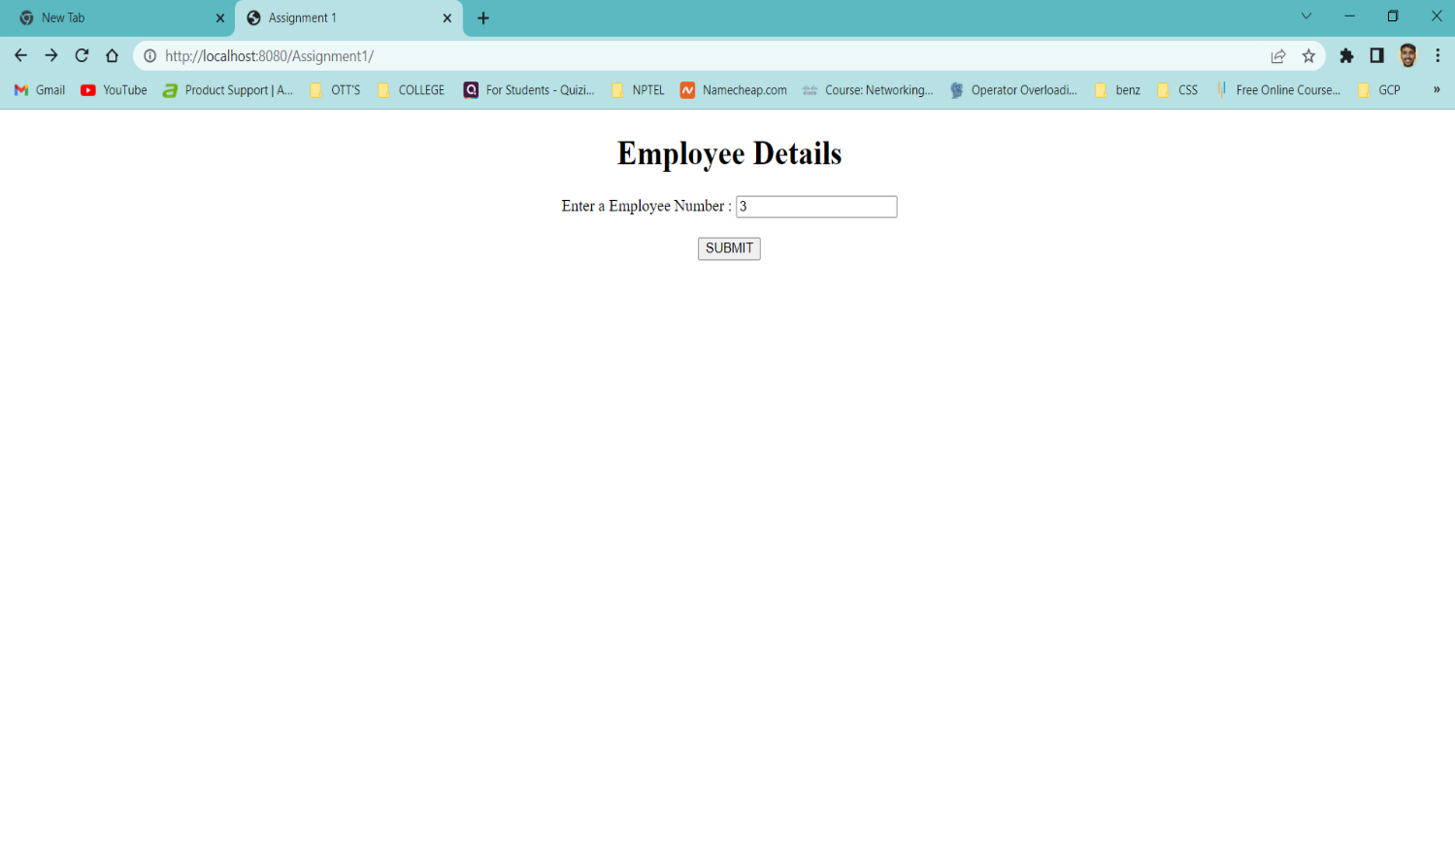

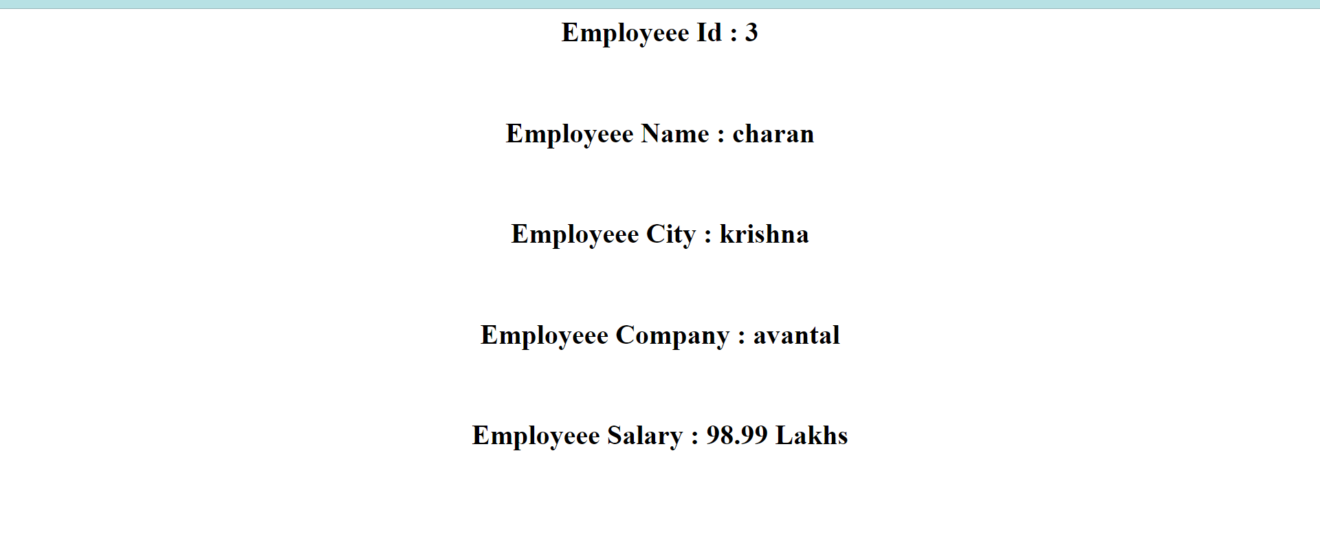

**Aim :** Create a Web Application that provides a web program to an end User and he

should be able to get the details in the form when it is Entered provide the

update control on the form to update the Employee information in the

database.

**Program :** Index.html

<html>

<head>

<title> Assignment 2 </title>

<meta charset="UTF-8">

<meta name="viewport" content="width=device-width, initial-scale=1.0">

</head>

<body>

<center>

<h1> <b> Book Details </b> </h1>

<form action = "Servlet1" method = "GET">

<label for = "is"> Enter Book ISBN Number : </label>

<input type = "text" name = "isbn" /> <br> <br>

<input type = "submit" value = "SUBMIT" />

</form>

</center>

</body>

</html>

**Program :** Book.html

<html>

<head>

<title> Book Details </title>

<meta charset="UTF-8">

<meta name="viewport" content="width=device-width, initial-scale=1.0">

</head>

<body>

<center>

<form action = "Servlet2" method = "GET">

<h1> <b> Update Book Details In Database </b> </h1>

<label for = "is1"> Enter ISBN Number : </label>

<input type="text" name="is1" /> <br> <br>

<label for = "au1"> Enter Book Name : </label>

<input type="text" name="au1" /> <br> <br>

<label for = "bo1"> Enter Book Price : </label>

<input type="text" name="bo1" /> <br> <br>

<input type = "submit" value = "UPDATE" />

</form>

</center>

</body>

</html>

**Program :** Servlet1.java

import java.io.IOException;

import java.io.PrintWriter;

import javax.servlet.ServletException;

import javax.servlet.http.HttpServlet;

import javax.servlet.http.HttpServletRequest;

import javax.servlet.http.HttpServletResponse;

import java.io.*;

import java.sql.*;

public class Servlet1 extends HttpServlet

{

@Override

protected void doGet(HttpServletRequest request, HttpServletResponse response) throws ServletException, IOException

{

response.setContentType("text/html"); //setting the content type

PrintWriter pw = response.getWriter(); //get the stream to write the data

int isbn = Integer.parseInt(request.getParameter("isbn"));

try

{

Class.forName("com.mysql.jdbc.Driver");

Connection con = DriverManager.getConnection("jdbc:mysql://localhost/it", "root", "");

PreparedStatement ps = con.prepareStatement("select * from newbook where isbn = ?");

ps.setInt(1, isbn);

ResultSet rs = ps.executeQuery();

while(rs.next())

{

pw.println("<center>");

pw.println("<h1> Book ISBN Number : " + rs.getInt(1) + "</h1> <br> <br>");

pw.println("<h1> Book Name : " + rs.getString(2) + "</h1> <br> <br>");

pw.println("<h1> Book Price : " + rs.getFloat(3) + "</h1> <br> <br>");

pw.println("</center>");

}

pw.println("<center>");

//pw.println("<h1> Execution Completed </h1>");

pw.println("<br> <br>");

pw.println("<form action = 'book.html'>");

pw.println("<input type = 'submit' value = 'EDIT' />");

pw.println("</form>");

pw.println("</center>");

}

catch(Exception e)

{

pw.println(e);

}

}

}

**Program :** Servlet2.java

import java.io.IOException;

import java.io.PrintWriter;

import javax.servlet.ServletException;

import javax.servlet.http.HttpServlet;

import javax.servlet.http.HttpServletRequest;

import javax.servlet.http.HttpServletResponse;

import java.io.*;

import java.sql.*;

public class Servlet2 extends HttpServlet

{

@Override

protected void doGet(HttpServletRequest request, HttpServletResponse response) throws ServletException, IOException

{

response.setContentType("text/html"); //setting the content type

PrintWriter pw = response.getWriter(); //get the stream to write the data

int isbn = Integer.parseInt(request.getParameter("is1"));

String author = request.getParameter("au1");

float price = Float.parseFloat(request.getParameter("bo1"));

try

{

Class.forName("com.mysql.jdbc.Driver");

Connection con = DriverManager.getConnection("jdbc:mysql://localhost/it", "root", "");

PreparedStatement ps = con.prepareStatement("update newbook set name = ?, price = ? where isbn = ?");

ps.setInt(3, isbn);

ps.setString(1, author);

ps.setFloat(2, price);

int check = ps.executeUpdate();

Statement st = con.createStatement();

ResultSet rs = st.executeQuery("select * from newbook");

while(rs.next())

{

pw.println("<center>");

pw.println("<h1> Book ISBN Number : " + rs.getInt(1) + "</h1> <br> <br>");

pw.println("<h1> Book Name : " + rs.getString(2) + "</h1> <br> <br>");

pw.println("<h1> Book Price : " + rs.getFloat(3) + "</h1> <br> <br>");

pw.println("<hr>");

pw.println("</center>");

}

pw.println("<center>");

pw.println("<h1> Execution Completed </h1>");

pw.println("<br> <br>");

pw.println("<form action = 'index.html'>");

pw.println("<input type = 'submit' value = 'Search' />");

pw.println("</form>");

pw.println("</center>");

}

catch(Exception e)

{

pw.println(e);

}

}

}

**Output :**

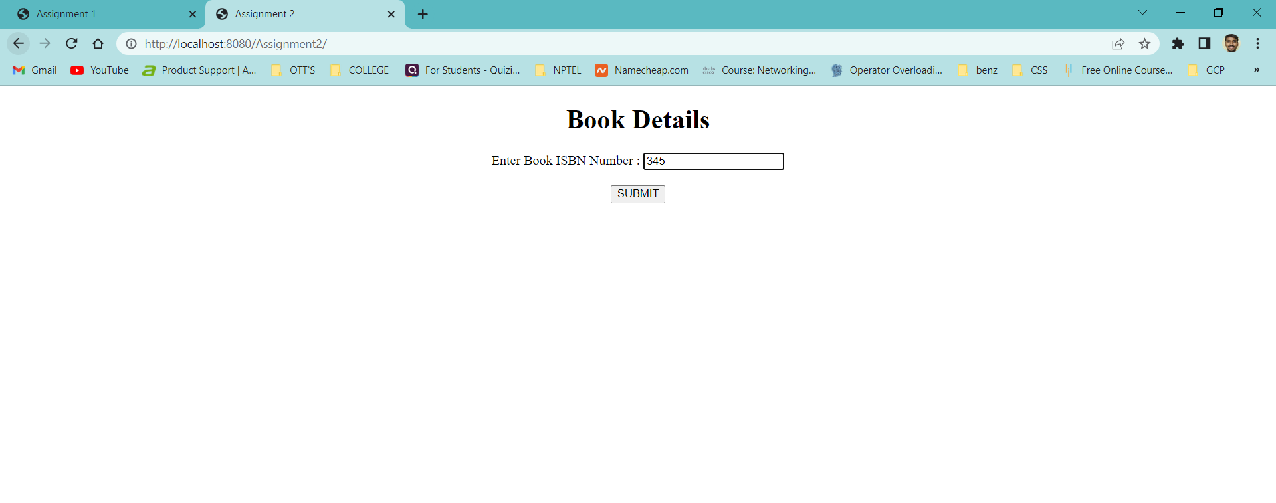

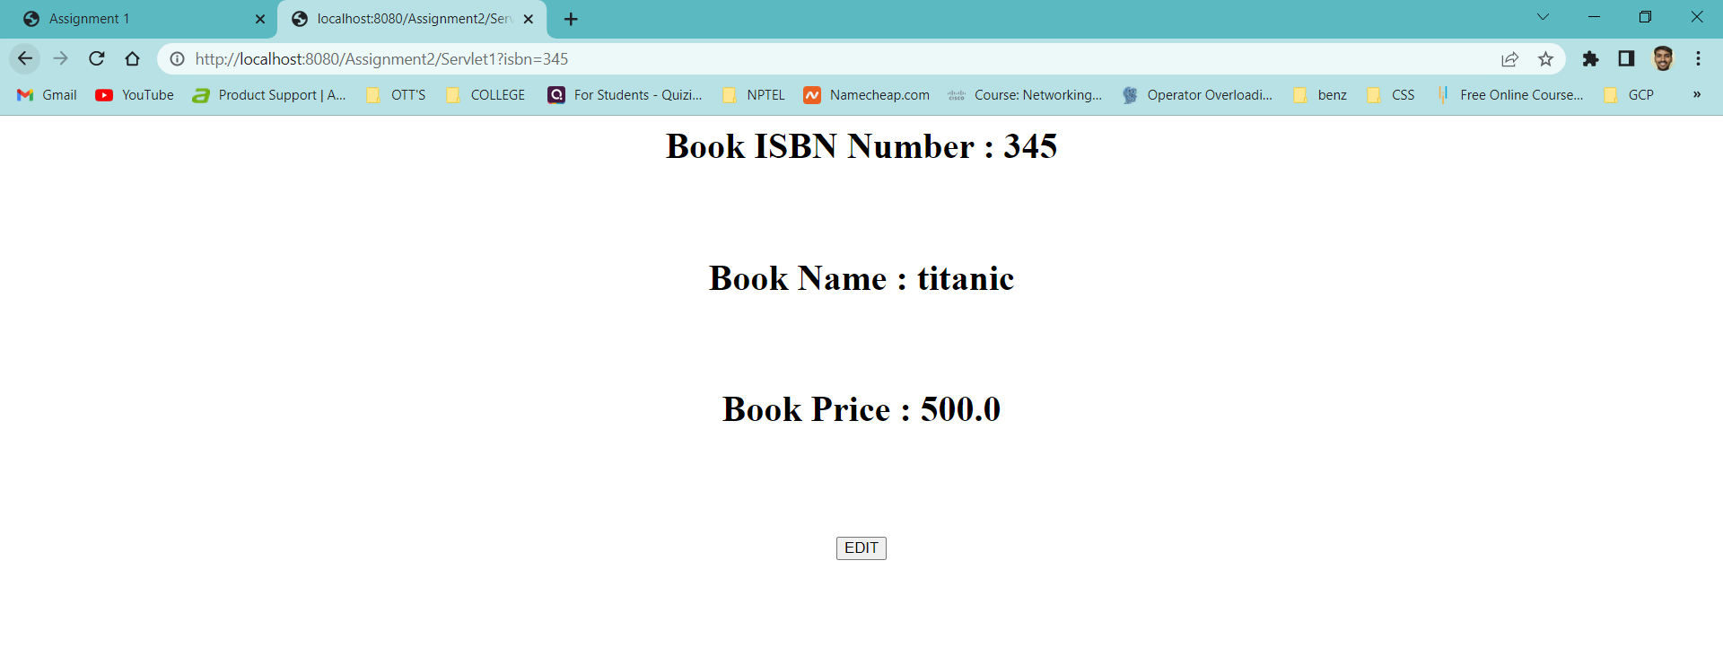

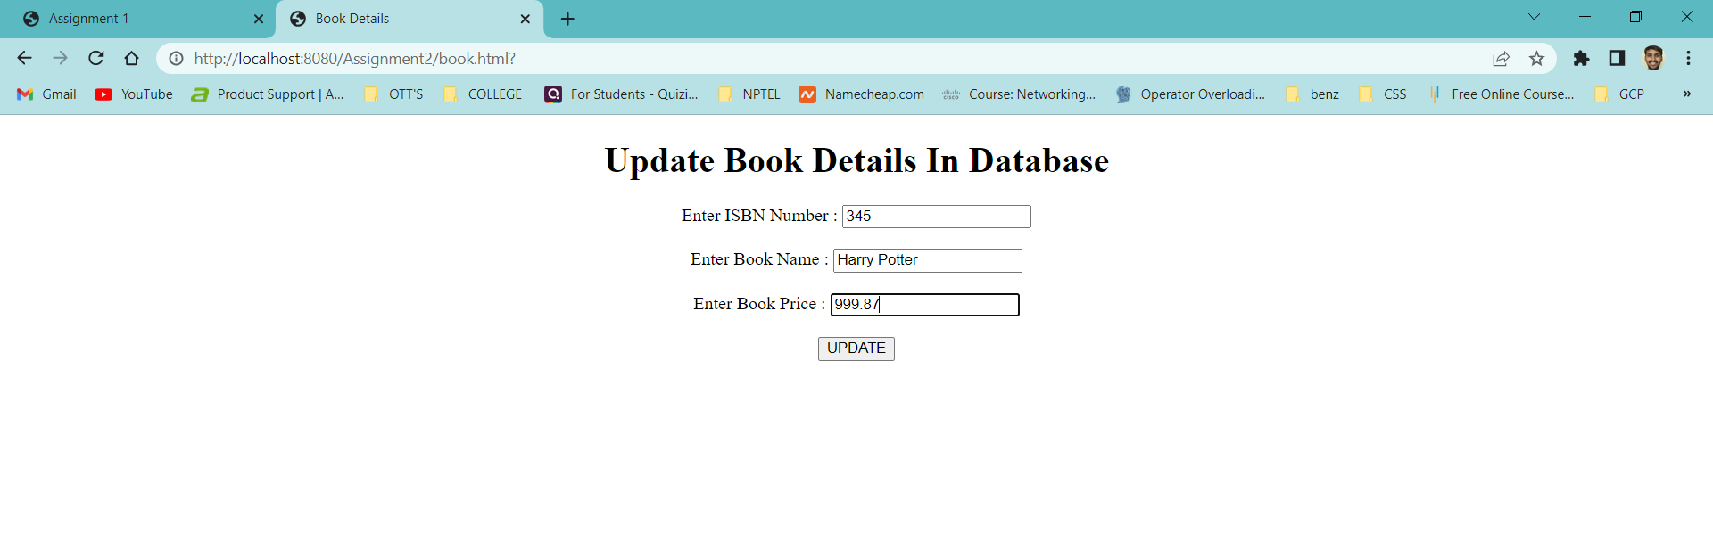

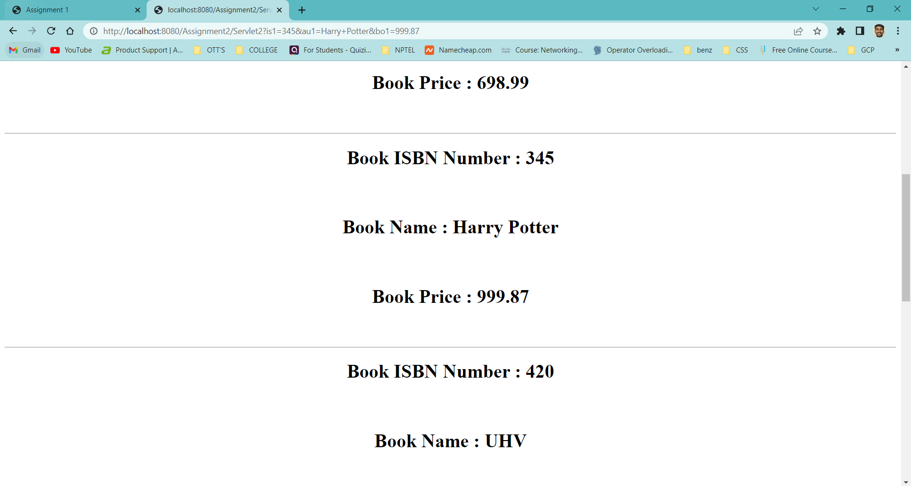

**Aim :** Create a Web application in which user enter the details of the Book are isbn, book

name, book cost in the web form insert those Details as a new record in the

database using servlets.

**Program :** Index.html

<html>

<head>

<title> Book Details </title>

<meta charset="UTF-8">

<meta name="viewport" content="width=device-width, initial-scale=1.0">

</head>

<body>

<center>

<form action = "Servlet1" method = "GET">

<h1> <b> Insert New Record Into Database </b> </h1>

<label for = "is1"> Enter Book ISBN Number : </label>

<input type="text" name="is1" /> <br> <br>

<label for = "au1"> Enter Book Name : </label>

<input type="text" name="au1" /> <br> <br>

<label for = "bo1"> Enter Book Price : </label>

<input type="text" name="bo1" /> <br> <br>

<input type = "submit" value = "SUBMIT" />

</form>

</center>

</body>

</html>

**Program :** Servlet1.java

import java.io.IOException;

import java.io.PrintWriter;

import javax.servlet.ServletException;

import javax.servlet.http.HttpServlet;

import javax.servlet.http.HttpServletRequest;

import javax.servlet.http.HttpServletResponse;

import java.io.*;

import java.sql.*;

public class Servlet1 extends HttpServlet

{

@Override

protected void doGet(HttpServletRequest request, HttpServletResponse response) throws ServletException, IOException

{

response.setContentType("text/html"); //setting the content type

PrintWriter pw = response.getWriter(); //get the stream to write the data

int isbn = Integer.parseInt(request.getParameter("is1"));

String name = request.getParameter("au1");

float price = Float.parseFloat(request.getParameter("bo1"));

try

{

Class.forName("com.mysql.jdbc.Driver");

Connection con = DriverManager.getConnection("jdbc:mysql://localhost/it", "root", "");

PreparedStatement ps = con.prepareStatement("insert into newbook values(?, ?, ?)");

ps.setInt(1, isbn);

ps.setString(2, name);

ps.setFloat(3, price);

int check = ps.executeUpdate();

Statement st = con.createStatement();

ResultSet rs = st.executeQuery("select * from newbook");

while(rs.next())

{

pw.println("<center>");

pw.println("<h1> Book ISBN Number : " + rs.getInt(1) + "</h1> <br> <br>");

pw.println("<h1> Book Name : " + rs.getString(2) + "</h1> <br> <br>");

pw.println("<h1> Book Price : " + rs.getFloat(3) + "</h1> <br> <br>");

pw.println("<hr>");

pw.println("</center>");

}

pw.println("<center>");

pw.println("<h1> Execution Completed </h1>");

pw.println("<br> <br>");

pw.println("<form action = 'index.html'>");

pw.println("<input type = 'submit' value = 'New Record' />");

pw.println("</form>");

pw.println("</center>");

}

catch(Exception e)

{

pw.println(e);

}

}

}

**Output :**

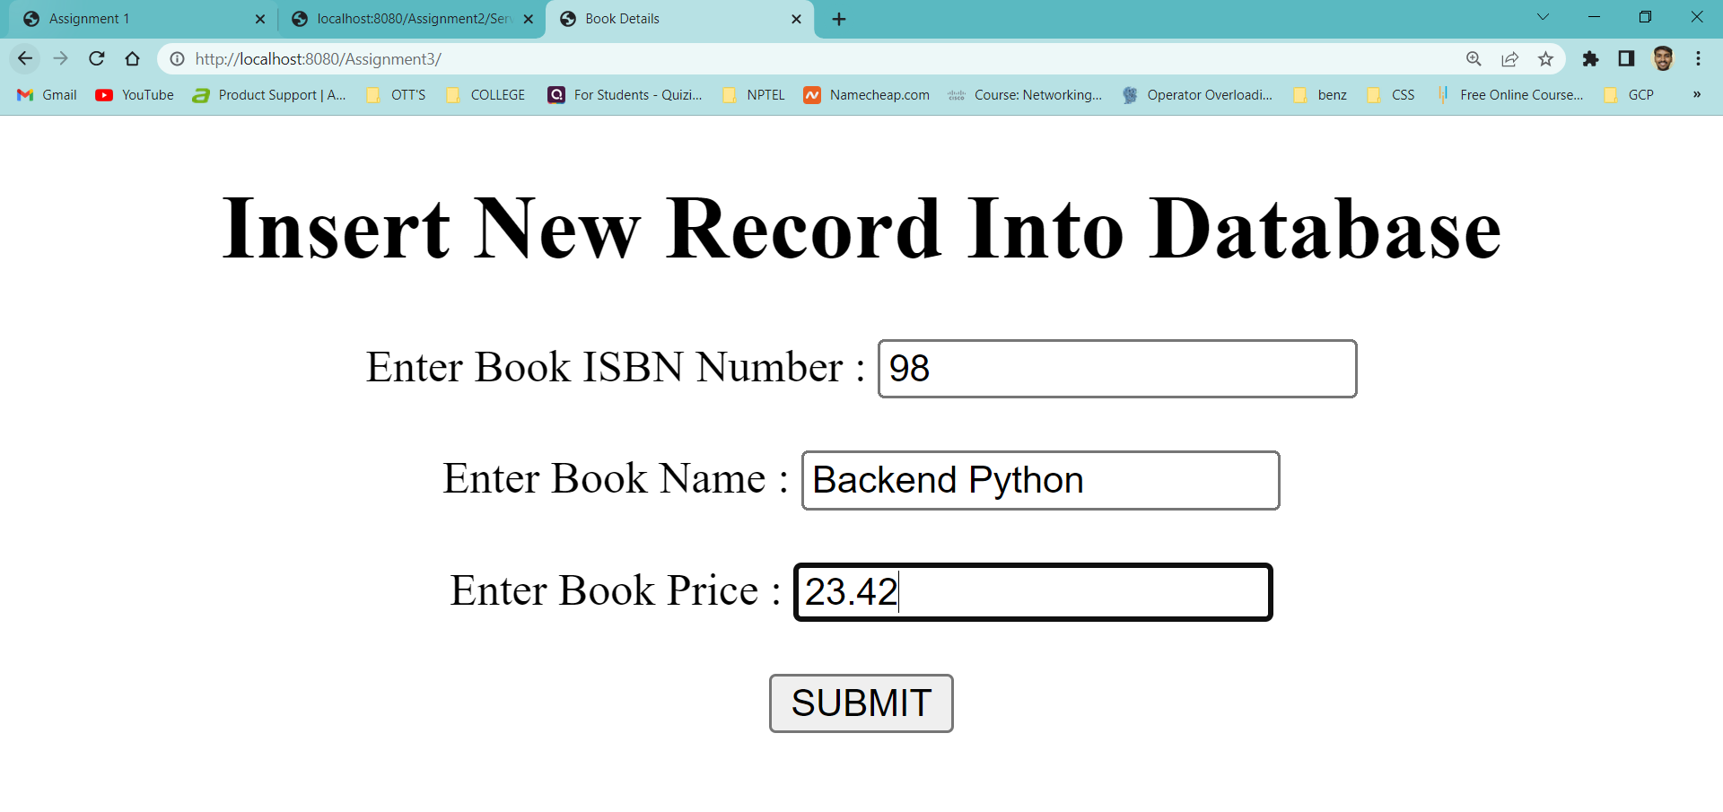

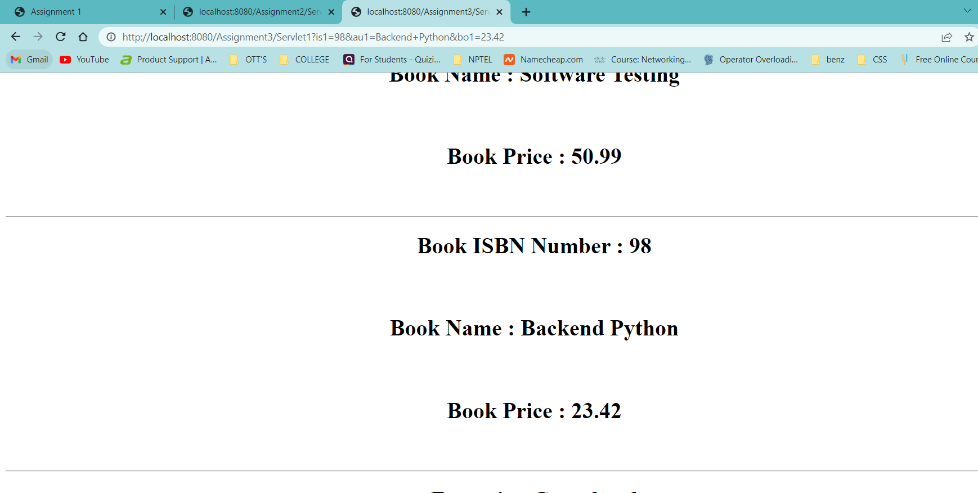

**Aim :** Create a Web application that gives a web form for the end user in Which end user

enters the salary range . server should sent to the Employee details whose salary are

beyond the range.

**Program :** Index.html

<html>

<head>

<title> Assignment - 4 </title>

<meta charset="UTF-8">

<meta name="viewport" content="width=device-width, initial-scale=1.0">

</head>

<body>

<center>

<form action = "Servlet1" method = "GET">

<h1> <b> Range Of Salary </b> </h1>

<label for = "mny"> Enter The Range Of Salary : </label>

<input type = "text" name = "sal" /> <br> <br>

<input type = "submit" value = "SUBMIT" />

</form>

</center>

</body>

</html>

**Program :** Servlet1.java

import java.io.IOException;

import java.io.PrintWriter;

import javax.servlet.ServletException;

import javax.servlet.http.HttpServlet;

import javax.servlet.http.HttpServletRequest;

import javax.servlet.http.HttpServletResponse;

import java.io.*;

import java.sql.*;

public class Servlet1 extends HttpServlet

{

@Override

protected void doGet(HttpServletRequest request, HttpServletResponse response) throws ServletException, IOException

{

response.setContentType("text/html"); //setting the content type

PrintWriter pw = response.getWriter(); //get the stream to write the data

int range = Integer.parseInt(request.getParameter("sal"));

try

{

Class.forName("com.mysql.jdbc.Driver");

Connection con = DriverManager.getConnection("jdbc:mysql://localhost/it", "root", "");

PreparedStatement ps = con.prepareStatement("select * from javaemployee where salary >= ?");

ps.setInt(1, range);

ResultSet rs = ps.executeQuery();

while(rs.next())

{

pw.println("<center>");

pw.println("<h1> Employeee Id : " + rs.getInt(1) + "</h1> <br> <br>");

pw.println("<h1> Employeee Name : " + rs.getString(2) + "</h1> <br> <br>");

pw.println("<h1> Employeee City : " + rs.getString(3) + "</h1> <br> <br>");

pw.println("<h1> Employeee Company : " + rs.getString(4) + "</h1> <br> <br>");

pw.println("<h1> Employeee Salary : " + rs.getFloat(5) + " Lakhs </h1> <br> <br>");

pw.println("<hr>");

pw.println("</center>");

}

pw.println("<center>");

//pw.println("<h1> Execution Completed </h1>");

pw.println("<br> <br>");

pw.println("<form action = 'index.html'>");

pw.println("<input type = 'submit' value = 'HOME' />");

pw.println("</form>");

pw.println("</center>");

}

catch(Exception e)

{

pw.println(e);

}

}

}

**Output :**

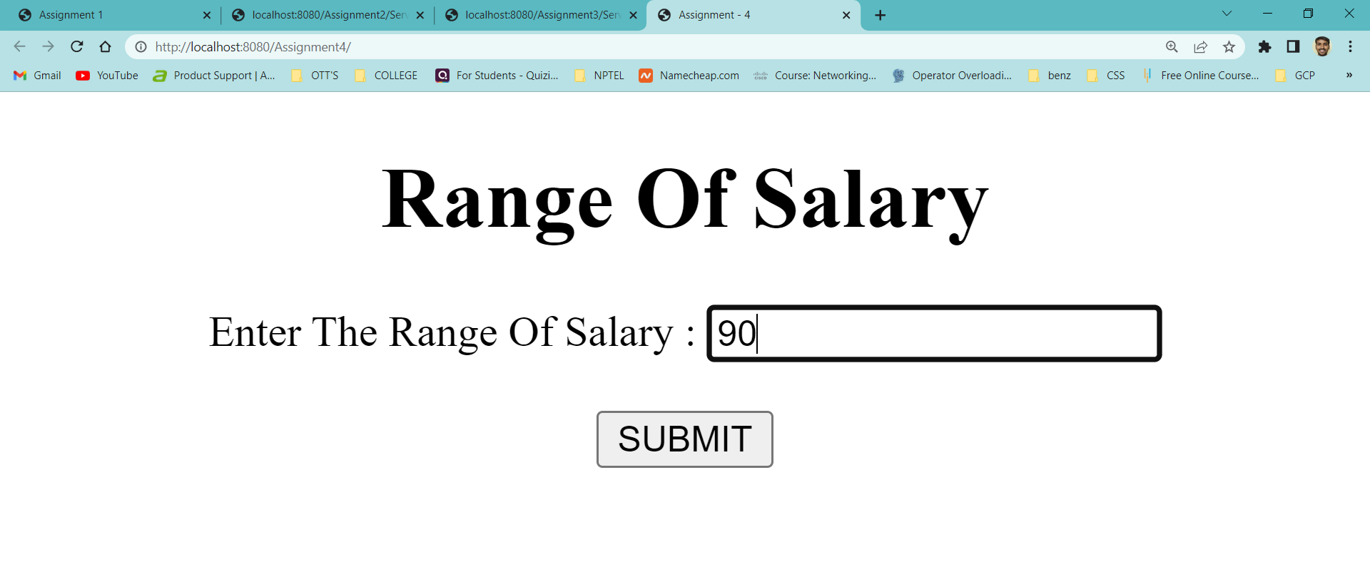

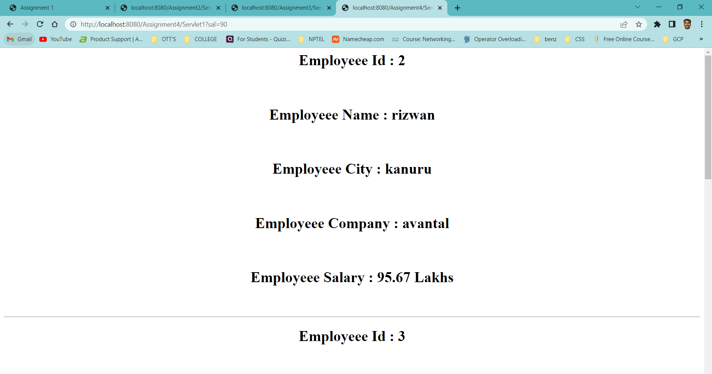

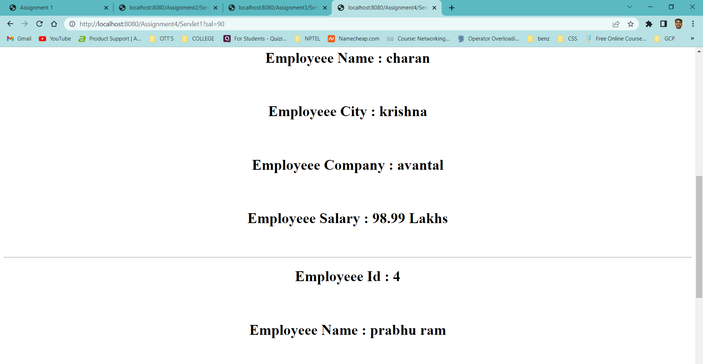

**WEEK – 7**

**Aim :** Create a web application for the Login and Logout Form using Servlets and cookies

where cookies stores the user information In the web browser.

**Program :** index.html

<html>

<head>

<title> Login & Logout Using Cookies </title>

<meta charset="UTF-8">

<meta name="viewport" content="width=device-width, initial-scale=1.0">

</head>

<body>

<center>

<a href="login.html"> Login </a>|

<a href="LogoutServlet"> Logout </a>|

<a href="ProfileServlet"> Profile </a>

<hr>

</center>

</body>

</html>

**Program :** link.html

<html>

<head>

<title> Link Web Page </title>

<meta charset="UTF-8">

<meta name="viewport" content="width=device-width, initial-scale=1.0">

</head>

<body>

<center>

<a href="login.html"> Login </a>|

<a href="LogoutServlet"> Logout </a>|

<a href="ProfileServlet"> Profile </a>

<hr>

</center>

</body> </html>

**Program :** login.html

<html>

<head>

<title>Login Web Page</title>

<meta charset="UTF-8">

<meta name="viewport" content="width=device-width, initial-scale=1.0">

</head>

<body bgcolor = "#ff8080">

<center>

<form action = "LoginServlet" method = "POST">

<h1> <strong> Login & Logout Using Cookies </strong> </h1>

<label for="un"> Enter Your Name : </label>

<input type = "text" name = "un" size = "25"/> <br> <br>

<label for="up"> Enter Your Password : </label>

<input type = "password" name = "up" /> <br> <br>

<input type = "submit" value = "Login" />

</form>

</center>

</body>

</html>

**Program :** LoginServlet.java

import java.io.IOException;

import java.io.PrintWriter;

import javax.servlet.ServletException;

import javax.servlet.http.Cookie;

import javax.servlet.http.HttpServlet;

import javax.servlet.http.HttpServletRequest;

import javax.servlet.http.HttpServletResponse;

public class LoginServlet extends HttpServlet

{

protected void doPost(HttpServletRequest request, HttpServletResponse response) throws ServletException, IOException

{

response.setContentType("text/html");

PrintWriter out = response.getWriter();

request.getRequestDispatcher("link.html").include(request, response);

String s1 = request.getParameter("un");

String s2 = request.getParameter("up");

if(s2.equals("admin"))

{

out.println("You Are Sucessfully Login");

out.println("<br> Welcome " + s1);

Cookie ck = new Cookie("name", s1);

response.addCookie(ck);

}

else

{

out.println("Error !!! UserName Or password Must be Wrong Please Check It Again ");

request.getRequestDispatcher("login.html").include(request, response);

}

out.close();

}

}

**Program :** LogoutServlet.java

import java.io.IOException;

import java.io.PrintWriter;

import javax.servlet.ServletException;

import javax.servlet.http.Cookie;

import javax.servlet.http.HttpServlet;

import javax.servlet.http.HttpServletRequest;

import javax.servlet.http.HttpServletResponse;

public class LogoutServlet extends HttpServlet

{

protected void doGet(HttpServletRequest request, HttpServletResponse response) throws ServletException, IOException

{

response.setContentType("text/html");

PrintWriter out = response.getWriter();

request.getRequestDispatcher("link.html").include(request, response);

Cookie ck = new Cookie("name", "");

ck.setMaxAge(0);

response.addCookie(ck);

out.println("You are Sucessfully Logout") } }

**Program :** ProfileServlet.java

import java.io.IOException;

import java.io.PrintWriter;

import javax.servlet.ServletException;

import javax.servlet.http.Cookie;

import javax.servlet.http.HttpServlet;

import javax.servlet.http.HttpServletRequest;

import javax.servlet.http.HttpServletResponse;

public class ProfileServlet extends HttpServlet

{

protected void doGet(HttpServletRequest request, HttpServletResponse response) throws ServletException, IOException

{

response.setContentType("text/html");

PrintWriter out = response.getWriter();

request.getRequestDispatcher("link.html").include(request, response);

Cookie ck[] = request.getCookies();

if(ck != null)

{

String name = ck[0].getValue();

if(!name.equals("") || name != null)

{

out.println("<b> Welcome to Profile </b> ");

out.println("Welcome" + name);

}

}

else

{

out.println("Please Login First");

request.getRequestDispatcher("login.html").include(request, response);

}

out.close();

}

}

**Output :**

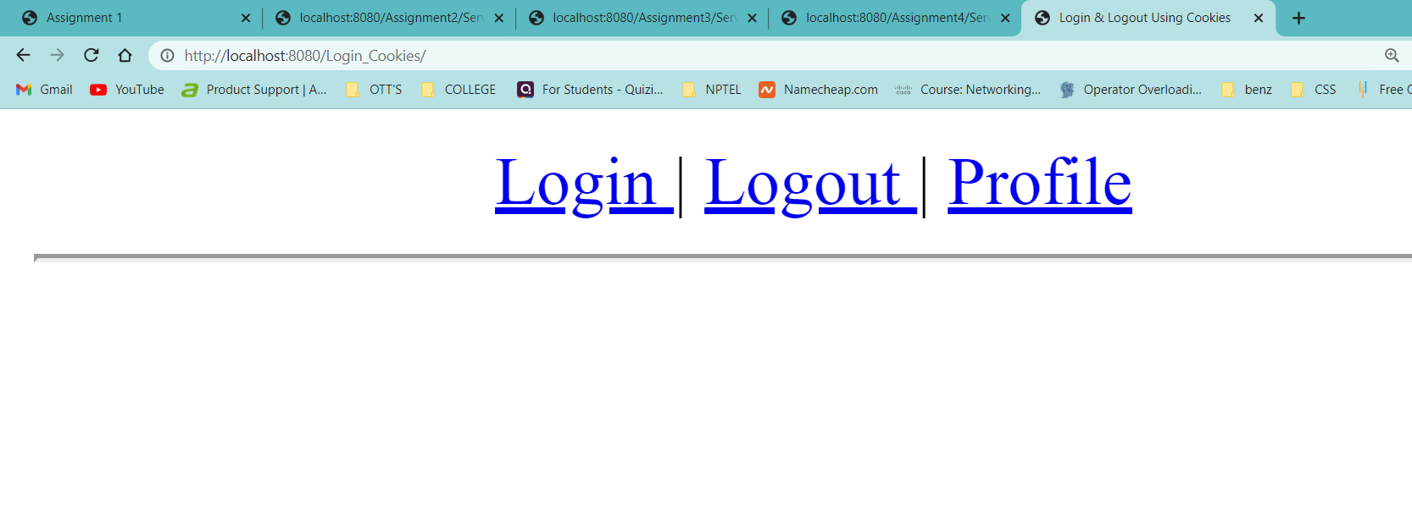

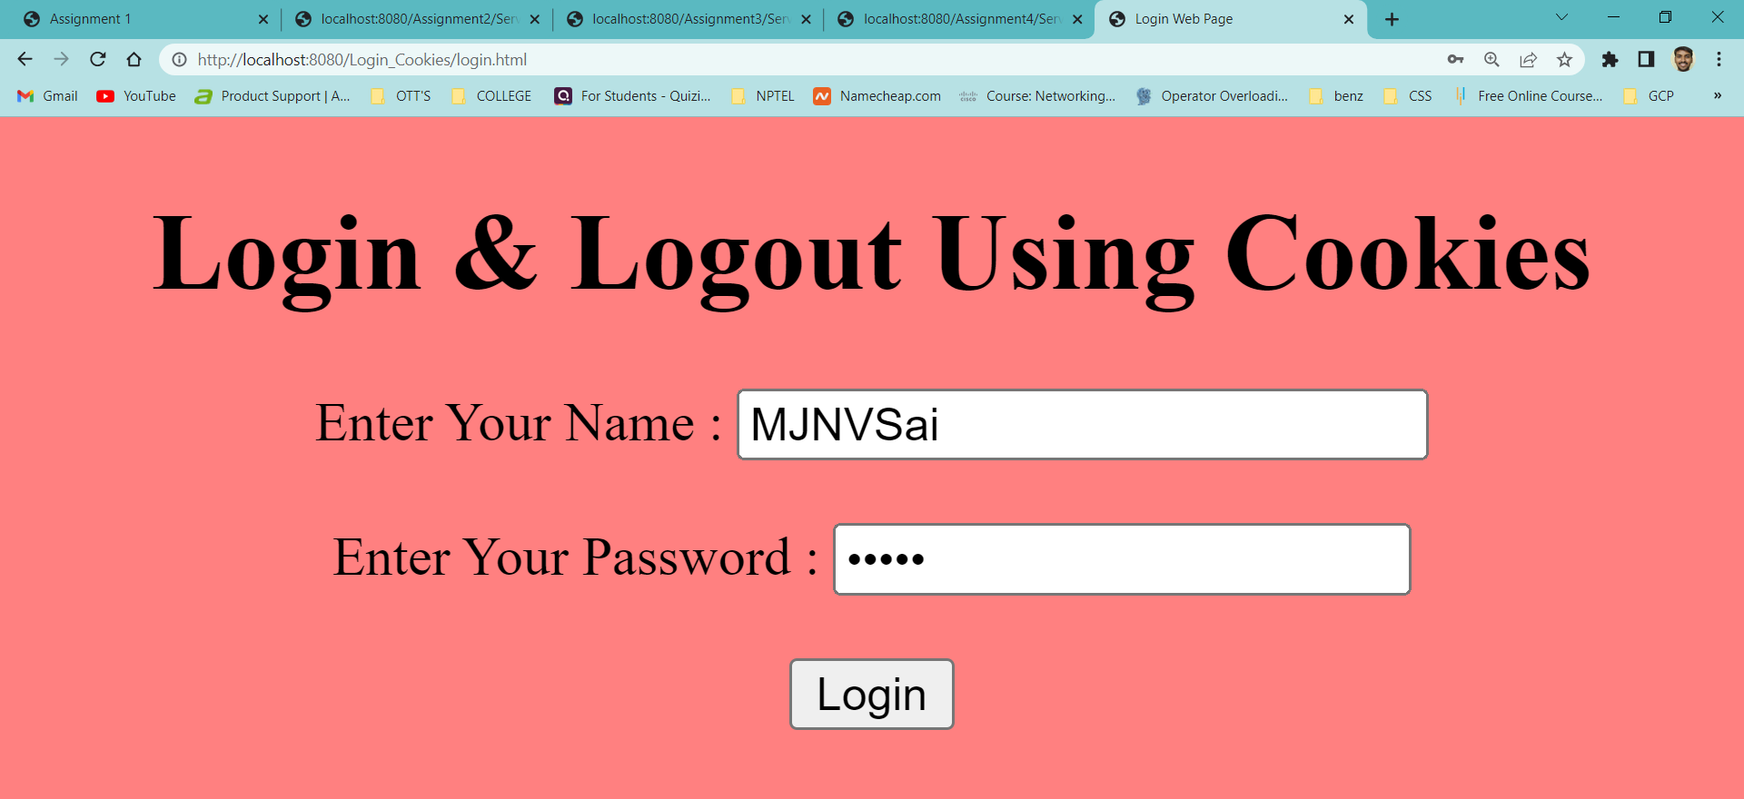

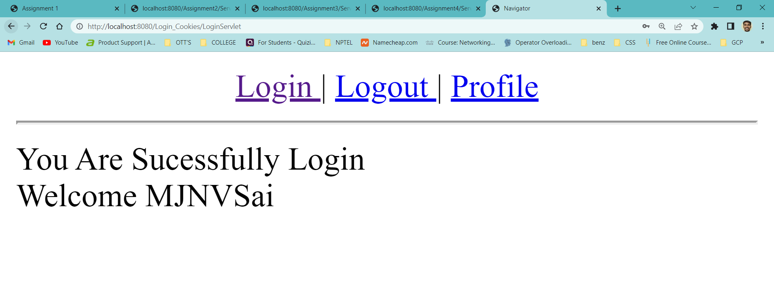

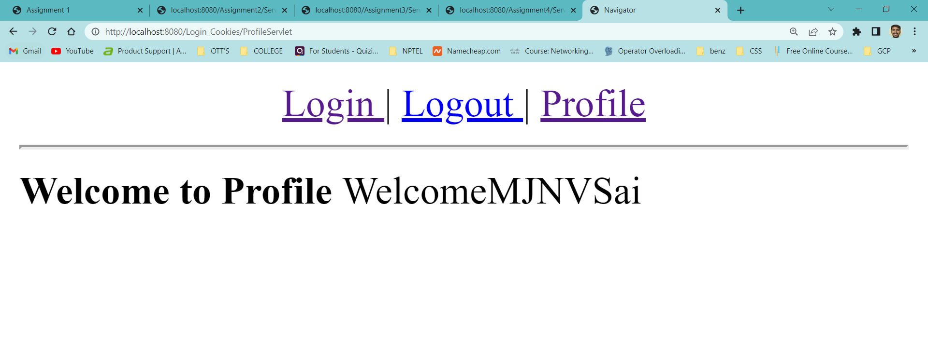

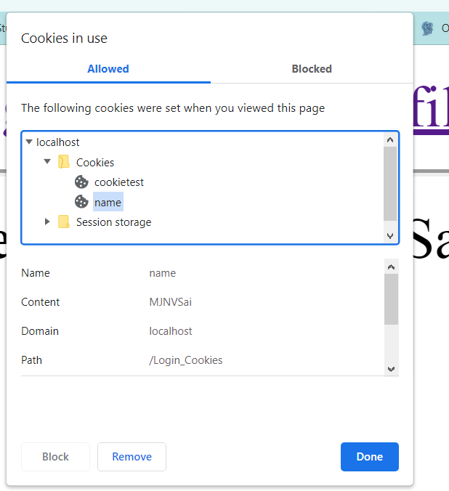

**Aim :** Create a web application in which, a web form allows the end user To perform online

transfer of funds from savings account to the Current account and it will update in

the database also.

**Program :** index.html

<html>

<head>

<title> Banking Application </title>

</head>

<body>

<center>

<h1> <b> <i> Online Fund Transfer Interface </i> </b> </h1>

<form action = "Transfer" method = "POST">

<label for = "sbno"> Enter Savings A/C Number : </label>

<input type="text" name="sbno" required /> <br> <br>

<label for = "cbno"> Enter Current A/C Number : </label>

<input type="text" name="cbno" required /> <br> <br>

<label for = "amount"> Enter Transfer : </label>

<input type="text" name="amount" required /> <br> <br>

<input type="submit" value="TRANSFER"/>

</form>

</center>

</body>

</html>

**Program :** web.xml

<?xml version="1.0" encoding="UTF-8"?>

<web-app version="3.1" xmlns="http://xmlns.jcp.org/xml/ns/javaee" xmlns:xsi="http://www.w3.org/2001/XMLSchema-instance" xsi:schemaLocation="http://xmlns.jcp.org/xml/ns/javaee http://xmlns.jcp.org/xml/ns/javaee/web-app_3_1.xsd">

<servlet>

<servlet-name>Transfer</servlet-name>

<servlet-class>Transfer</servlet-class>

<init-param>

<param-name>Driver</param-name>

<param-value>com.mysql.jdbc.Driver</param-value>

</init-param>

<init-param>

<param-name>DriverUrl</param-name>

<param-value>jdbc:mysql://localhost/it</param-value>

</init-param>

<init-param>

<param-name>Username</param-name>

<param-value>root</param-value>

</init-param>

<init-param>

<param-name>Password</param-name>

<param-value></param-value>

</init-param>

</servlet>

<servlet-mapping>

<servlet-name>Transfer</servlet-name>

<url-pattern>/Transfer</url-pattern>

</servlet-mapping>

<session-config>

<session-timeout>

30

</session-timeout>

</session-config>

</web-app>

**Program :** Transfer.java

import java.io.*;

import java.sql.*;

import java.lang.*;

import java.util.*;

import javax.servlet.*;

import javax.servlet.http.*;

//main code starts from here

public class Transfer extends HttpServlet

{

Connection con;

public void init(ServletConfig config) throws ServletException

{

try

{

String driver = config.getInitParameter("Driver");

String url = config.getInitParameter("DriverUrl");

String user = config.getInitParameter("Username");

String pwd = config.getInitParameter("Password");

Class.forName(driver);

con = DriverManager.getConnection(url, user, pwd);

}

catch(Exception e)

{

System.out.println(e);

}

}

public void doPost(HttpServletRequest req,HttpServletResponse res) throws ServletException,IOException

{

Statement st = null;

int sbaccno = Integer.parseInt(req.getParameter("sbno"));

int caccno = Integer.parseInt(req.getParameter("cbno"));

float amount = Float.parseFloat(req.getParameter("amount"));

res.setContentType("text/html");

PrintWriter out = res.getWriter();

out.println("<html>");

out.println("<body bgcolor='azure'>");

try

{

st = con.createStatement();

String sql1 = "update savings set balance = balance-" +amount+ "where accno=" +sbaccno;

String sql2 = "update current set balance = balance+" +amount+ "where accno=" +caccno;

if(sbaccno != caccno)

{

st.executeUpdate(sql1);

st.executeUpdate(sql2);

out.println("<h2> <b> <i> Funds Transfered Successfully ! </i> </b> </h2>");

}

else

{

out.println("Saving or Current Bank Account Number was incorrect. Please check and try again ! <a href='index.html'> Click here </a>");

}

}

catch(Exception e)

{

System.out.println(e);

}

finally

{

try

{

if(st!=null)

{

st.close();

}

}

catch(Exception e)

{

e.printStackTrace();

}

}

out.println("</body>");

out.println("</html>");

}

public void destroy()

{

try

{

if(con!=null)

{

con.close();

}

}

catch(Exception e)

{

e.printStackTrace();

}

}

}

**Output :**

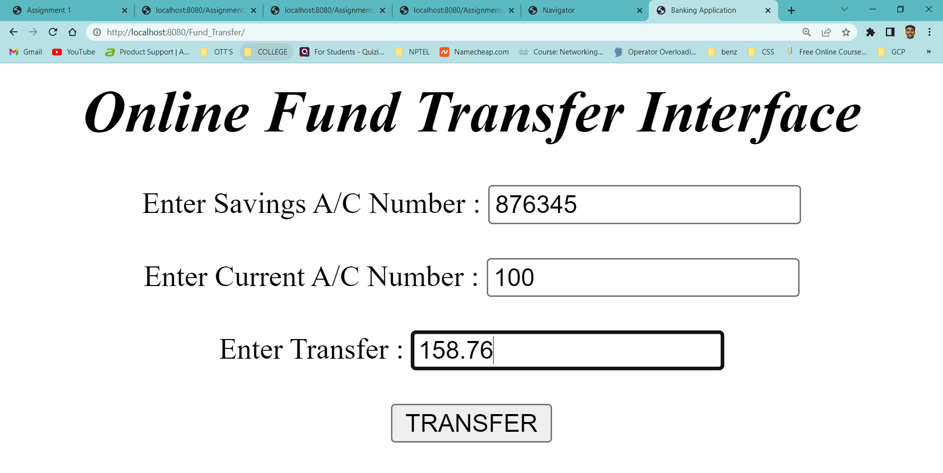

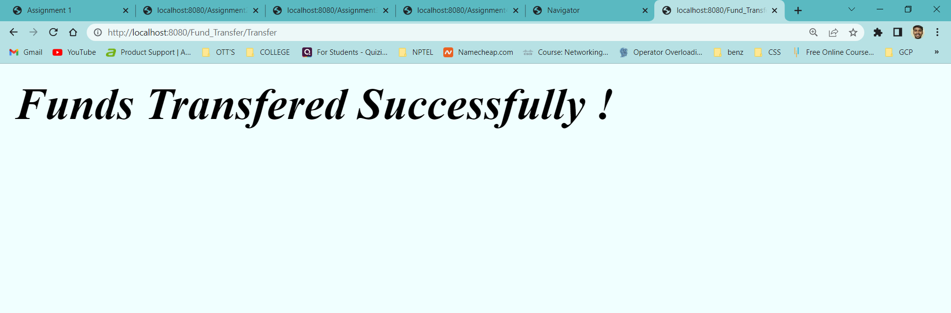

**Invalid Input :**

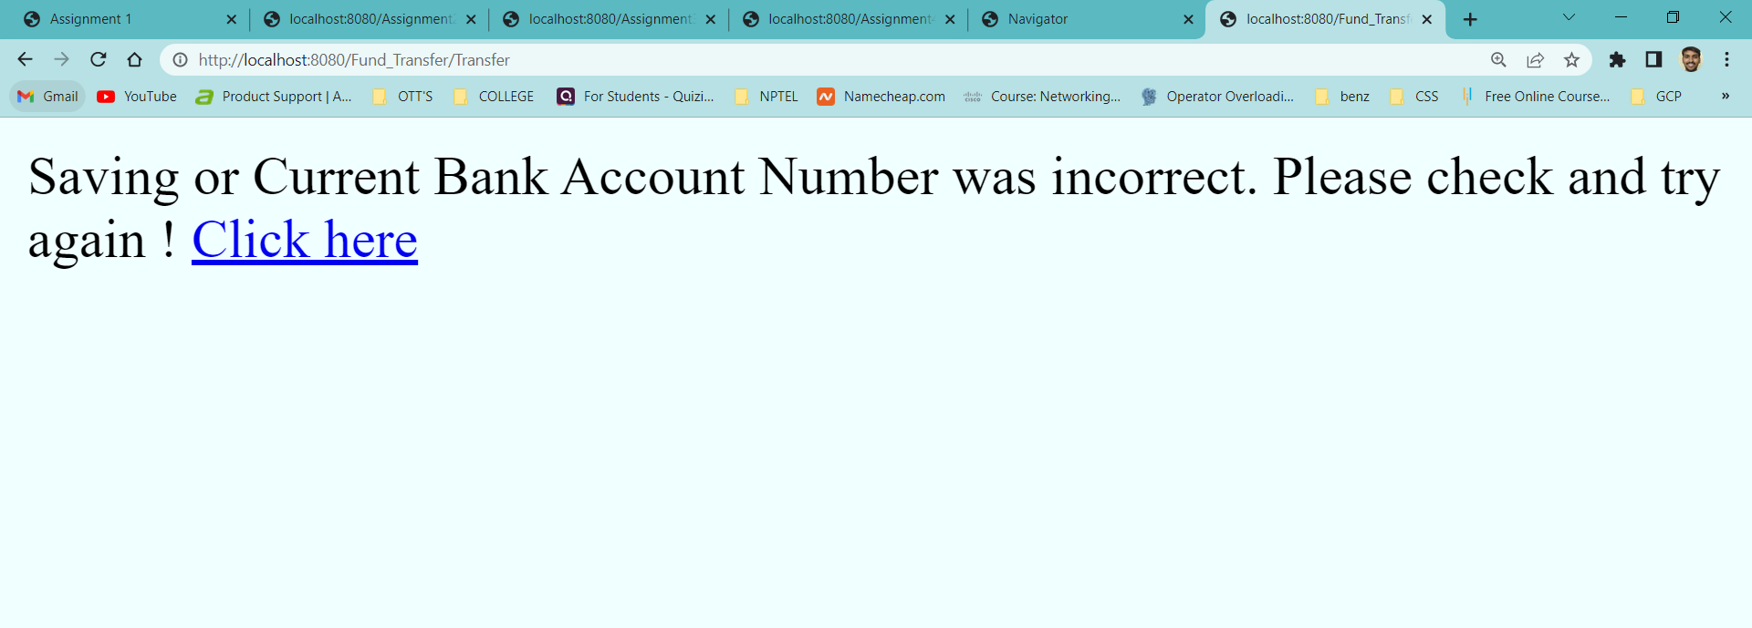

**WEEK – 8**

**Aim :**  Create a Web Application Which Shows the product code and product quantity on

User side of an web page and create a session in which session holds the product

Code and quatity of that product

**Program :** index.html

<html>

<head>

<title> Session Tracking </title>

<meta charset="UTF-8">

<meta name="viewport" content="width=device-width, initial-scale=1.0">

</head>

<body>

<center>

<h1> Welcome to The Shopping Mall </h1>

<form action = "Servlet1" method = "GET">

<label for = "a1"> Select Product Code : </label>

<select name = "pCode">

<option value = 101> 101

<option value = 102> 102

<option value = 103> 103

<option value = 104> 104

<option value = 105> 105

</select> <br> <br>

<label for = "a2"> Product Quantity : </label>

<input type = "text" name = "qty" /> <br> <br>

<input type = "submit" name = "submit" value = "ADD ITEM" />

<input type = "submit" name = "submit" value = "REMOVE ITEM" />

<input type = "submit" name = "submit" value = "SHOW ITEMS" />

<input type = "submit" name = "submit" value = "PAY AMOUNT" />

<input type = "submit" name = "submit" value = "LOGOUT" />

</form>

</center>

</body> </html>

**Program :** Servlet1.java

import java.io.*;

import javax.servlet.*;

import java.util.*;

import javax.servlet.http.HttpServlet;

import javax.servlet.http.HttpServletRequest;

import javax.servlet.http.HttpServletResponse;

import javax.servlet.http.HttpSession;

public class Servlet1 extends HttpServlet

{

HttpSession session;

String pCode, qty, clickButton;

public void doGet(HttpServletRequest req, HttpServletResponse res) throws ServletException, IOException

{

res.setContentType("text/html");

PrintWriter pw = res.getWriter();

session = req.getSession(true);

clickButton = req.getParameter("submit");

if(clickButton.equals("ADD ITEM"))

{

pCode = req.getParameter("pCode");

qty = req.getParameter("qty");

if(!pCode.equals("") || qty.equals(""))

{

session.setAttribute(pCode, qty);

res.sendRedirect("./index.html");

}

}

else if(clickButton.equals("REMOVE ITEM"))

{

pCode = req.getParameter("pCode");

session.removeAttribute(pCode);

res.sendRedirect("./index.html");

}

else if(clickButton.equals("SHOW ITEMS"))

{

Enumeration e = session.getAttributeNames();

if(e.hasMoreElements())

{

pw.println("<h1> Your Shopping Cart Items </h1>");

while(e.hasMoreElements())

{

String code = (String)e.nextElement();

pw.println("<h1> Product Code : " + code + "</h1>");

pw.println("<h1> Quantity : " + session.getAttribute(code) + "</h1>");

}

}

else

{

pw.println("<h1> No Items Please </h1>");

}

}

else if(clickButton.equals("LOGOUT"))

{

session.invalidate();

res.sendRedirect("./index.html");

}

else if(clickButton.equals("PAY AMOUNT"))

{

pw.println("<h1> Payment Logic Goes Here </h1>");

}

pw.close();

}

}

**Output :**

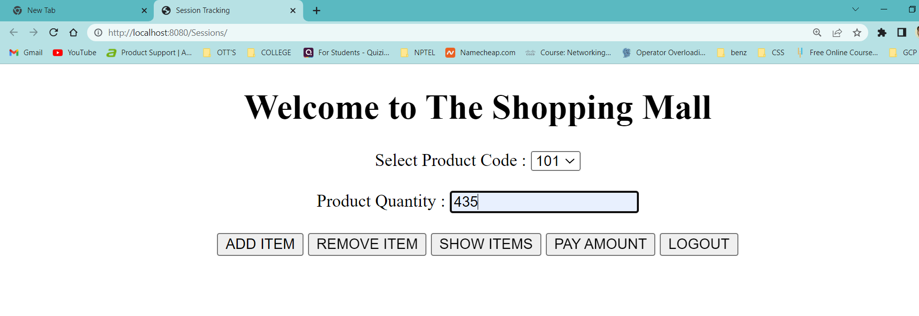

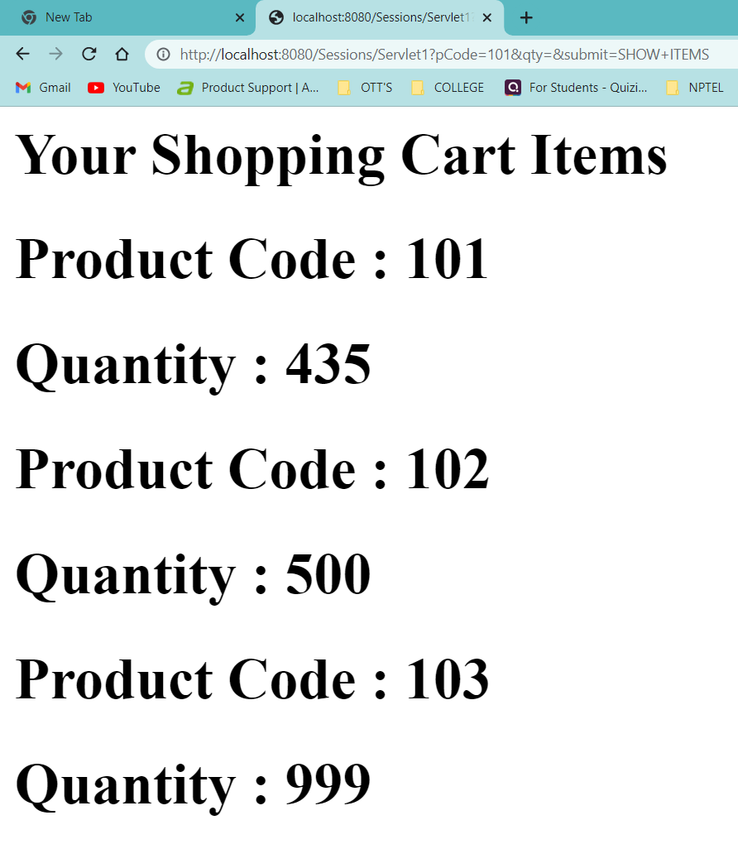

**Result :** Sucessfully Executed The Program.

**Company Mailer Project**

**Aim :** Create A mailer Web application for a company that can be used by the employees

of the company only. It can be run on interanet. Each user can send mails, receive

mails and delete mails after getting logged in!

**DataBase Tables :**

**Table – 1 :**

create database companymail;

create table company_mailer_user(

ID bigint, NAME varchar(4000), EMAIL varchar(4000),

PASSWORD varchar(4000), GENDER varchar(4000), DOB date,

ADDRESSLINE varchar(4000), CITY varchar(4000), STATE varchar(4000),

COUNTRY varchar(4000), CONTACT varchar(4000), REGISTEREDDATE date, AUTHORIZED varchar(4000),

primary key(ID)

);

**Table – 2:**

create table company_mailer_message(

ID bigint, SENDER varchar(4000), RECEIVER varchar(4000), SUBJECT varchar(4000),

MESSAGE varchar(4000), TRASH varchar(4000), MESSAGEDATE date,

primary key(ID)

);

* Create Both These tables in Mysql Database

**Program :**  index.html

<html>

<head>

<title> Index Web Page</title>

<meta charset="UTF-8">

<meta name="viewport" content="width=device-width, initial-scale=1.0">

<style>

.inputform

{

float:left;

width:400px;

border:1px solid pink;

border-radius:10px;

padding:10px;

}

.inputform table tr td input,textarea,select

{

width:200px;

}

#gender1,#gender2

{

width:10px;

}

#submit

{

margin-left:100px;

width:100px;

}

#reset

{

width:100px;

}

.design

{

background-color:red;

color:white;

padding-left:100px;

}

</style>

</head>

<body>

<!-- header -->

<center> <h1> <b> Company Mailer </b> </h1> </center>

<h3 style="background-color:red;color:red;">c</h3>

<!-- body -->

<div class="inputform">

<h1 class="design"> <b> Registration Form </b> </h1>

<form action="RegisterServlet" method="post">

<table>

<tr><td>ID : </td><td><input type="text" name="regid"/></td></tr>

<tr><td>Name:</td><td><input type="text" name="name"/></td></tr>

<tr><td>Email:</td><td><input type="text" name="email"/>@cmailer.com</td></tr>

<tr><td>Password:</td><td><input type="password" name="password"/></td></tr>

<tr><td>Gender:</td><td><input id="gender1" type="radio" name="gender" value="male"/>Male

<input type="radio" id="gender2" name="gender" value="female"/>Female

</td></tr>

<tr><td>Date Of Birth:</td><td><input type="date" name="dob"/></td></tr>

<tr><td>AddressLine:</td><td><textarea name="addressLine" rows="5" cols="15"></textarea></td></tr>

<tr><td>City:</td><td><input type="text" name="city"/></td></tr>

<tr><td>State:</td><td><input type="text" name="state"/></td></tr>

<tr><td>Country:</td><td><select name="country">

<option>Select-Country:</option>

<option>India</option>

<option>Pakistan</option>

<option>China</option>

<option>Bhutan</option>

<option>USA</option>

<option>France</option>

<option>Other</option>

</select></td></tr>

<tr><td>Contact:</td><td><input type="text" name="contact"/></td></tr>

<tr><td colspan="2"><input id="submit" type="submit" value="register"/>

<input id="reset" type="reset" value="clear"/>

</td></tr>

</table>

</form>

</div>

<div class="inputform" style="float:right;">

<h1 class="design"> <b> Login Form </b> </h1>

<form action="LoginServlet" method="post">

<table>

<tr><td>Email:</td><td><input type="email" name="email"/></td></tr>

<tr><td>Password:</td><td><input type="password" name="password"/></td></tr>

<tr><td colspan="2"><input id="submit" type="submit" value="login"/>

</td></tr>

</table>

</form>

</div>

</body>

</html>

**Program :** composeform.html

<html>

<head>

<title> Compose Form Web Page </title>

<meta charset="UTF-8">

<meta name="viewport" content="width=device-width, initial-scale=1.0">

</head>

<body>

<center>

<div class="inputform" style="float:left;">

<h1 class="design"> <b> Compose Mail Form </b> </h1>

<form action="ComposeServletProcess">

<table>

<tr><td>ID : </td><td><input type="text" name="id1"/></td></tr>

<tr><td>To:</td><td><input type="text" name="to"/></td></tr>

<tr><td>Subject:</td><td><input type="text" name="subject"/></td></tr>

<tr><td colspan="2">Message:</td><td></tr>

<tr><td colspan="2"><textarea name="message" rows="5" cols="30"></textarea></td></tr>

<tr><td colspan="2"><input id="submit" type="submit" value="Send Mail"/>

</td></tr>

</table>

</form>

</div>

</center>

</body>

</html>

**Program :** footer.html

<!DOCTYPE html>

<!--

To change this license header, choose License Headers in Project Properties.

To change this template file, choose Tools | Templates

and open the template in the editor.

-->

<html>

<head>

<title> Footer Web Page </title>

<meta charset="UTF-8">

<meta name="viewport" content="width=device-width, initial-scale=1.0">

</head>

<body>

<h3 style="margin-top:500px;background-color:red;color:white;text-align:center"> <b> &copy; &nbsp; Copyright 2011-2050. All rights reserved! </b> </h3>

</body>

</html>

**Program :** header.html

<html>

<head>

<title> Header Web Page</title>

<meta charset="UTF-8">

<meta name="viewport" content="width=device-width, initial-scale=1.0">

<style>

.inputform

{

float:left;

width:400px;

border:1px solid pink;

border-radius:10px;

padding:10px;

}

.inputform table tr td input,textarea,select

{

width:200px;

}

#gender1,#gender2

{

width:10px;

}

#submit

{

margin-left:100px;

width:100px;

}

#reset

{

width:100px;

}

.design

{

background-color:red;

color:white;

padding-left:100px;

}

</style>

</head>

<body>

<center> <h1> <b> Company Mailer </b> </h1> </center>

<h3 style="background-color:red;color:red;"> c </h3>

</body>

</html>

**Program :**  link.html

<html>

<head>

<title> Link Web Page </title>

<meta charset="UTF-8">

<meta name="viewport" content="width=device-width, initial-scale=1.0">

<style>

.anchor

{

/* Box Model */

padding: 5px;

margin: 10px; /* 20px */

border-radius: 9px; /* 520px */

border-color: blue;

border-style: double;

border-width: 2px; /* 5px */

color: crimson;

text-decoration: none;

letter-spacing: 2px;

}

.anchor:hover

{

color: white;

background-color: indianred;

/*transition-delay: 0.7s;*/

}

</style>

</head>

<body>

<center>

<br> <br>

<a href="index.html" class="anchor"> Home </a> |

<a href="InboxServlet" class="anchor"> Inbox </a> |

<a href="ComposeServlet" class="anchor"> Compose Mail </a> |

<a href="SentServlet" class="anchor"> Sent Mail </a> |

<a href="TrashServlet" class="anchor"> Trash </a> |

<a href="LogoutServlet" class="anchor"> Logout </a>

<br> <br>

<hr/>

</center>

</body>

</html>

**Program :**  login.html

<html>

<head>

<title> Login Web Page</title>

<meta charset="UTF-8">

<meta name="viewport" content="width=device-width, initial-scale=1.0">

</head>

<body>

<div class="inputform" style="float:left;">

<h2 class="design">Login Form</h2>

<form action="LoginServlet" method="post">

<table>

<tr><td>Email:</td><td><input type="email" name="email"/></td></tr>

<tr><td>Password:</td><td><input type="password" name="password"/></td></tr>

<tr><td colspan="2"><input id="submit" type="submit" value="login"/>

</td></tr>

</table>

</form>

</div>

</body>

</html>

**Program :** RegisterServlet.java

import java.io.*;

import javax.servlet.*;

import javax.servlet.ServletException;

import javax.servlet.annotation.WebServlet;

import javax.servlet.http.HttpServlet;

import javax.servlet.http.HttpServletRequest;

import javax.servlet.http.HttpServletResponse;

import java.sql.*;

import java.text.SimpleDateFormat;

import java.time.*;

public class RegisterServlet extends HttpServlet

{

public void doPost(HttpServletRequest request, HttpServletResponse response) throws ServletException, IOException

{

response.setContentType("text/html");

PrintWriter out = response.getWriter();

request.getRequestDispatcher("header.html").include(request, response);

String rid = request.getParameter("regid");

String name = request.getParameter("name");

String password = request.getParameter("password");

String email = request.getParameter("email") + "@cmailer.com";

String gender = request.getParameter("gender");

//String dob = request.getParameter("dob");

LocalDate dob = LocalDate.parse(request.getParameter("dob"));

String addressLine = request.getParameter("addressLine");

String city = request.getParameter("city");

String state = request.getParameter("state");

String country = request.getParameter("country");

String contact = request.getParameter("contact");

try

{

int status = 0;

Date sqlDob = Date.valueOf(dob);

// Getting Current Date

java.sql.Date sqlCurrentDate = null;

java.util.Date utilDate = java.util.Calendar.getInstance().getTime();

sqlCurrentDate = new java.sql.Date(utilDate.getTime());

String insertsql = "insert into company_mailer_user(id,name,email,password,gender,dob,addressLine,city,state,country,contact,registereddate,authorized) values(?,?,?,?,?,?,?,?,?,?,?,?,?)";

Class.forName("com.mysql.jdbc.Driver");

Connection con = DriverManager.getConnection("jdbc:mysql://localhost/companymail", "root", "");

PreparedStatement ps = con.prepareStatement(insertsql);

ps.setString(1, rid);

ps.setString(2, name);

ps.setString(3, email);

ps.setString(4, password);

ps.setString(5, gender);

ps.setDate(6, sqlDob);

ps.setString(7, addressLine);

ps.setString(8, city);

ps.setString(9, state);

ps.setString(10, country);

ps.setString(11, contact);

ps.setDate(12, sqlCurrentDate);

ps.setString(13, "yes");

status = ps.executeUpdate();

if(status > 0)

{

out.println("<h1> You are Sucessfully Registred </h1>");

request.getRequestDispatcher("login.html").include(request, response);

}

}

catch(Exception e)

{

out.println("<h1> An Error Occured " + e + "</h1>");

}

finally

{

request.getRequestDispatcher("footer.html").include(request, response);

out.close();

}

}

}

**Program :** LoginServlet.java

import java.io.*;

import javax.servlet.*;

import javax.servlet.ServletException;

import javax.servlet.annotation.WebServlet;

import javax.servlet.http.HttpServlet;

import javax.servlet.http.HttpServletRequest;

import javax.servlet.http.HttpServletResponse;

import java.sql.*;

import java.text.SimpleDateFormat;

import java.time.*;

public class LoginServlet extends HttpServlet

{

public void doPost(HttpServletRequest request, HttpServletResponse response) throws ServletException, IOException

{

response.setContentType("text/html");

PrintWriter out = response.getWriter();

request.getRequestDispatcher("header.html").include(request, response);

String email = request.getParameter("email");

String password = request.getParameter("password");

try

{

boolean status = false;

Class.forName("com.mysql.jdbc.Driver");

Connection con = DriverManager.getConnection("jdbc:mysql://localhost/companymail", "root", "");

String selectsql = "select * from company_mailer_user where email = ? and password = ? and authorized = ?";

PreparedStatement ps = con.prepareStatement(selectsql);

ps.setString(1, email);

ps.setString(2, password);

ps.setString(3, "yes");

ResultSet rs = ps.executeQuery();

if(rs.next())

{

status = true;

}

if(status)

{

request.getSession().setAttribute("login", "true");

request.getSession().setAttribute("email", email);

response.sendRedirect("InboxServlet"); // Created The Servlet

//response.sendRedirect("./index.html");

}

else

{

out.print("<h1> Sorry, username or password Invalid </h1>");

request.getRequestDispatcher("login.html").include(request, response);

}

}

catch(Exception e)

{

out.println("<h1> An Error Occured " + e + "</h1>");

}

finally

{

request.getRequestDispatcher("footer.html").include(request, response);

out.close();

}

}

}

**Program :** InboxServlet.java

import java.io.*;

import javax.servlet.*;

import javax.servlet.ServletException;

import javax.servlet.annotation.WebServlet;

import javax.servlet.http.HttpServlet;

import javax.servlet.http.HttpServletRequest;

import javax.servlet.http.HttpServletResponse;

import java.sql.*;

import java.text.SimpleDateFormat;

import java.time.*;

import javax.servlet.http.HttpSession;

public class InboxServlet extends HttpServlet

{

public void doGet(HttpServletRequest request, HttpServletResponse response) throws ServletException, IOException

{

response.setContentType("text/html");

PrintWriter out = response.getWriter();

request.getRequestDispatcher("header.html").include(request, response);

request.getRequestDispatcher("link.html").include(request, response);

HttpSession session = request.getSession(false);

if(session == null)

{

response.sendRedirect("./index.html");

}

else

{

String email = (String)session.getAttribute("email");

String mainrec = (String)session.getAttribute("Torec");

out.print("<span style='float:right'> <h2> <b> Hi, " + email + "</b> </h2> </span>");

out.print("<h1> <strong> Inbox <strong> </h1>");

String msg = (String)request.getAttribute("msg");

if(msg != null)

{

out.print("<h3> <b> " +msg+ "</b> </h3>");

}

try

{

Class.forName("com.mysql.jdbc.Driver");

Connection con = DriverManager.getConnection("jdbc:mysql://localhost/companymail", "root", "");

String selectsql = "select * from company_mailer_message where sender = ? and trash = 'no' order by id desc";

PreparedStatement ps = con.prepareStatement(selectsql);

//ps.setString(1, "manju@gmail.com");

ps.setString(1, email);

ResultSet rs = ps.executeQuery();

out.println("<center>");

out.print("<table border='1' style='width:700px;'>");

out.print("<tr style='background-color:grey;color:white'><td> <center> Sender </center> </td><td> <center> Subject </center> </td></tr>");

while(rs.next())

{

out.print("<tr><td>" +rs.getString(2)+ "</td><td> <a href='ViewMailServlet?id=" +rs.getString(1)+ "'>" +rs.getString(4)+ "</a></td></tr>");

}

out.print("</table>");

out.println("</center>");

con.close();

}

catch(Exception e)

{

out.println("<h1> An Error Occured " + e + "</h1>");

}

}

request.getRequestDispatcher("footer.html").include(request, response);

out.close();

}

public void doPost(HttpServletRequest request, HttpServletResponse response) throws ServletException, IOException

{

doGet(request,response);

}

}

**Program :** ComposeServlet.java

import java.io.*;

import javax.servlet.*;

import javax.servlet.ServletException;

import javax.servlet.annotation.WebServlet;

import javax.servlet.http.HttpServlet;

import javax.servlet.http.HttpServletRequest;

import javax.servlet.http.HttpServletResponse;

import java.sql.*;

import java.text.SimpleDateFormat;

import java.time.*;

import javax.servlet.http.HttpSession;

public class ComposeServlet extends HttpServlet

{

public void doGet(HttpServletRequest request, HttpServletResponse response) throws ServletException, IOException

{

response.setContentType("text/html");

PrintWriter out = response.getWriter();

request.getRequestDispatcher("header.html").include(request, response);

request.getRequestDispatcher("link.html").include(request, response);

HttpSession session=request.getSession(false);

if(session == null)

{

response.sendRedirect("index.html");

}

else

{

String email = (String)session.getAttribute("email");

out.print("<span style='float:right'> <h2> <b> Hi, " +email+ " </b> </h2> </span>");

String msg = (String)request.getAttribute("msg");

if(msg != null)

{

// request.setAttribute("Torec", email);

out.print("<p>" +msg+ "</p>");

}

request.getRequestDispatcher("composeform.html").include(request, response);

}

request.getRequestDispatcher("footer.html").include(request, response);

out.close();

}

}

**Program :** ComposeServletProcess.java

import java.io.*;

import javax.servlet.*;

import javax.servlet.ServletException;

import javax.servlet.annotation.WebServlet;

import javax.servlet.http.HttpServlet;

import javax.servlet.http.HttpServletRequest;

import javax.servlet.http.HttpServletResponse;

import java.sql.*;

import java.text.SimpleDateFormat;

import java.time.*;

import javax.servlet.http.HttpSession;

public class ComposeServletProcess extends HttpServlet

{

public void doGet(HttpServletRequest request, HttpServletResponse response) throws ServletException, IOException

{

response.setContentType("text/html");

PrintWriter out = response.getWriter();

request.getRequestDispatcher("header.html").include(request, response);

String receiver = request.getParameter("to");

String id1 = request.getParameter("id1");

String subject = request.getParameter("subject");

String message = request.getParameter("message");

message = message.replaceAll("\n", "<br>");

String email = (String)request.getSession(false).getAttribute("email");

try

{

int status = 0;

Class.forName("com.mysql.jdbc.Driver");

Connection con = DriverManager.getConnection("jdbc:mysql://localhost/companymail", "root", "");

String insertmsg = "insert into company_mailer_message(id,sender,receiver,subject,message,trash,messagedate) values(?,?,?,?,?,?,?)";

PreparedStatement ps = con.prepareStatement(insertmsg);

java.sql.Date sqlCurrentDate = null;

java.util.Date utilDate = java.util.Calendar.getInstance().getTime();

sqlCurrentDate = new java.sql.Date(utilDate.getTime());

ps.setString(1, id1);

ps.setString(2, email);

ps.setString(3, receiver);

ps.setString(4, subject);

ps.setString(5, message);

ps.setString(6, "no");

ps.setDate(7, sqlCurrentDate);

status = ps.executeUpdate();

if(status > 0)

{

request.setAttribute("msg", "message successfully sent");

request.setAttribute("Torec", receiver);

request.getRequestDispatcher("ComposeServlet").forward(request, response);

}

}

catch(Exception e)

{

out.println("<h1> An Error Occured " + e + "</h1>");

}

finally

{

request.getRequestDispatcher("footer.html").include(request, response);

out.close();

}

} }

**Program :**  ViewMailServlet.java

import java.io.*;

import javax.servlet.*;

import javax.servlet.ServletException;

import javax.servlet.annotation.WebServlet;

import javax.servlet.http.HttpServlet;

import javax.servlet.http.HttpServletRequest;

import javax.servlet.http.HttpServletResponse;

import java.sql.*;

import java.text.SimpleDateFormat;

import java.time.*;

import javax.servlet.http.HttpSession;

public class ViewMailServlet extends HttpServlet

{

public void doGet(HttpServletRequest request, HttpServletResponse response) throws ServletException, IOException

{

response.setContentType("text/html");

PrintWriter out = response.getWriter();

request.getRequestDispatcher("header.html").include(request, response);

request.getRequestDispatcher("link.html").include(request, response);

HttpSession session=request.getSession(false);

if(session == null)

{

response.sendRedirect("index.html");

}

else

{

String email = (String)session.getAttribute("email");

out.print("<span style='float:right'> <h2> <b> Hi, " +email+ " </b> </h2> </span>");

int id = Integer.parseInt(request.getParameter("id"));

try

{

Class.forName("com.mysql.jdbc.Driver");

Connection con = DriverManager.getConnection("jdbc:mysql://localhost/companymail", "root", "");

String selectview = "select * from company_mailer_message where id = ?";

PreparedStatement ps = con.prepareStatement(selectview);

ps.setInt(1, id);

ResultSet rs = ps.executeQuery();

if(rs.next())

{

out.print("<style>");

out.println(".anchor{padding: 5px; margin: 10px; border-radius: 9px; border-color: blue; border-style: double; border-width: 2px; color: crimson; text-decoration: none; letter-spacing: 2px;}");

out.println("</style>");

out.print("<h1> <b> " +rs.getString("subject")+ "</b> </h1> <hr/>");

out.print("<center>");

out.print("<p><b> <h3> Message: </h3> </b> " +rs.getString("message")+ "</p>");

out.println("<p> <b> Sender : </b> " +rs.getString("sender")+ "</p> ");

out.println("<p> <b> Receiver : </b> " +rs.getString("receiver")+ "</p> ");

out.print("<p><a href='DeleteMailServlet?id=" +rs.getString(1)+ "' class='anchor'> Delete Mail </a></p>");

out.print("</center>");

}

con.close();

}

catch(Exception e)

{

out.println("<h1> An Error Occured " + e + "</h1>");

}

}

request.getRequestDispatcher("footer.html").include(request, response);

out.close();

}

}

**Program :**  DeleteMailServlet.java

import java.io.*;

import javax.servlet.*;

import javax.servlet.ServletException;

import javax.servlet.annotation.WebServlet;

import javax.servlet.http.HttpServlet;

import javax.servlet.http.HttpServletRequest;

import javax.servlet.http.HttpServletResponse;

import java.sql.*;

import java.text.SimpleDateFormat;

import java.time.*;

import javax.servlet.http.HttpSession;

public class DeleteMailServlet extends HttpServlet

{

public void doGet(HttpServletRequest request, HttpServletResponse response) throws ServletException, IOException

{

response.setContentType("text/html");

PrintWriter out = response.getWriter();

request.getRequestDispatcher("header.html").include(request, response);

request.getRequestDispatcher("link.html").include(request, response);

HttpSession session=request.getSession(false);

if(session == null)

{

response.sendRedirect("index.html");

}

else

{

String email = (String)session.getAttribute("email");

out.print("<span style='float:right'> <h2> <b> Hi, " +email+ " </b> </h2> </span>");

int id = Integer.parseInt(request.getParameter("id"));

try

{

Class.forName("com.mysql.jdbc.Driver");

Connection con = DriverManager.getConnection("jdbc:mysql://localhost/companymail", "root", "");

String delquery = "update company_mailer_message set trash = ? where id = ?";

PreparedStatement ps = con.prepareStatement(delquery);

ps.setString(1, "yes");

ps.setInt(2, id);

int i = ps.executeUpdate();

if(i > 0)

{

request.setAttribute("msg","Mail successfully deleted!");

request.getRequestDispatcher("InboxServlet").forward(request, response);

}

con.close();

}

catch(Exception e)

{

out.println("<h1> An Error Occured " + e + "</h1>");

}

}

request.getRequestDispatcher("footer.html").include(request, response);

out.close();

}

}

**Program :**  SentServlet.java

import java.io.*;

import javax.servlet.*;

import javax.servlet.ServletException;

import javax.servlet.annotation.WebServlet;

import javax.servlet.http.HttpServlet;

import javax.servlet.http.HttpServletRequest;

import javax.servlet.http.HttpServletResponse;

import java.sql.*;

import java.text.SimpleDateFormat;

import java.time.*;

import javax.servlet.http.HttpSession;

public class SentServlet extends HttpServlet

{

public void doGet(HttpServletRequest request, HttpServletResponse response) throws ServletException, IOException

{

response.setContentType("text/html");

PrintWriter out = response.getWriter();

request.getRequestDispatcher("header.html").include(request, response);

request.getRequestDispatcher("link.html").include(request, response);

HttpSession session=request.getSession(false);

if(session == null)

{

response.sendRedirect("index.html");

}

else

{

String email = (String)session.getAttribute("email");

out.print("<span style='float:right'> <h2> <b> Hi, " +email+ " </b> </h2> </span>");

out.print("<h1> <b> Sent Mail </b> </h1>");

try

{

Class.forName("com.mysql.jdbc.Driver");

Connection con = DriverManager.getConnection("jdbc:mysql://localhost/companymail", "root", "");

String sendsql = "select * from company_mailer_message where sender = ? and trash = 'no' order by id desc";

PreparedStatement ps = con.prepareStatement(sendsql);

ps.setString(1, email);

ResultSet rs = ps.executeQuery();

out.print("<center>");

out.print("<table border='2' style='width:700px;'>");

out.print("<tr style='background-color:grey;color:white'><td> <center> To </center> </td><td> <center> Subject </center></td></tr>");

while(rs.next())

{

out.print("<tr><td>" +rs.getString("receiver")+ "</td><td><a href='ViewMailServlet?id=" +rs.getString(1)+ "'>" +rs.getString("subject")+ "</a></td></tr>");

}

out.print("</table>");

out.print("</center>");

con.close();

}

catch(Exception e)

{

out.println("<h1> An Error Occured " + e + "</h1>");

}

}

request.getRequestDispatcher("footer.html").include(request, response);

out.close();

}

}

**Program :** TrashServelt.java

import java.io.*;

import javax.servlet.*;

import javax.servlet.ServletException;

import javax.servlet.annotation.WebServlet;

import javax.servlet.http.HttpServlet;

import javax.servlet.http.HttpServletRequest;

import javax.servlet.http.HttpServletResponse;

import java.sql.*;

import java.text.SimpleDateFormat;

import java.time.*;

import javax.servlet.http.HttpSession;

public class TrashServlet extends HttpServlet

{

public void doGet(HttpServletRequest request, HttpServletResponse response) throws ServletException, IOException

{

response.setContentType("text/html");

PrintWriter out = response.getWriter();

request.getRequestDispatcher("header.html").include(request, response);

request.getRequestDispatcher("link.html").include(request, response);

HttpSession session=request.getSession(false);

if(session == null)

{

response.sendRedirect("index.html");

}

else

{

String email = (String)session.getAttribute("email");

out.print("<span style='float:right'> <h2> <b> Hi, " +email+ " </b> </h2> </span>");

out.print("<h1> <b> Trash </b> </h1>");

String msg = (String)request.getAttribute("msg");

if(msg != null)

{

out.print("<p>" +msg+ "</p>");

}

try

{

Class.forName("com.mysql.jdbc.Driver");

Connection con = DriverManager.getConnection("jdbc:mysql://localhost/companymail", "root", "");

String trashsql = "select * from company_mailer_message where receiver = ? OR sender = ? and trash = ? order by id desc";

PreparedStatement ps = con.prepareStatement(trashsql);

ps.setString(1, email);

ps.setString(2, email);

ps.setString(3, "yes");

ResultSet rs = ps.executeQuery();

out.print("<center>");

out.print("<table border='2' style='width:700px;'>");

out.print("<tr style='background-color:grey;color:white'><td> <center> Sender </center> </td><td> <center> Subject </center></td></tr>");

while(rs.next())

{

out.print("<tr><td>" +rs.getString("sender")+ "</td><td>" +rs.getString("subject")+ "</td></tr>");

}

out.print("</table>");

out.print("</center>");

con.close();

}

catch(Exception e)

{

out.println("<h1> An Error Occured " + e + "</h1>");

}

}

request.getRequestDispatcher("footer.html").include(request, response);

out.close();

}

}

**Program :** LogoutServlet.java

import java.io.*;

import javax.servlet.*;

import javax.servlet.ServletException;

import javax.servlet.annotation.WebServlet;

import javax.servlet.http.HttpServlet;

import javax.servlet.http.HttpServletRequest;

import javax.servlet.http.HttpServletResponse;

import java.sql.*;

import java.text.SimpleDateFormat;

import java.time.*;

import javax.servlet.http.HttpSession;

public class LogoutServlet extends HttpServlet

{

public void doGet(HttpServletRequest request, HttpServletResponse response) throws ServletException, IOException

{

response.setContentType("text/html");

PrintWriter out = response.getWriter();

request.getRequestDispatcher("header.html").include(request, response);

request.getSession().invalidate();

out.print("<center> <h1> <b> You are successfully logged out! </b> </h1> </center>");

request.getRequestDispatcher("login.html").include(request, response);

request.getRequestDispatcher("footer.html").include(request, response);

out.close();

}

}

**Outputs :**

**Register :**

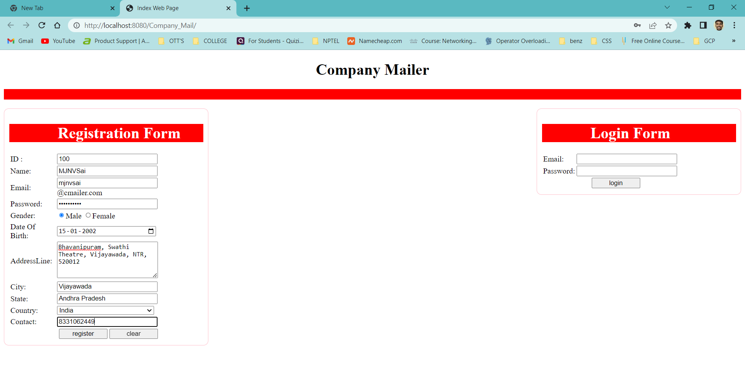

**Login :**

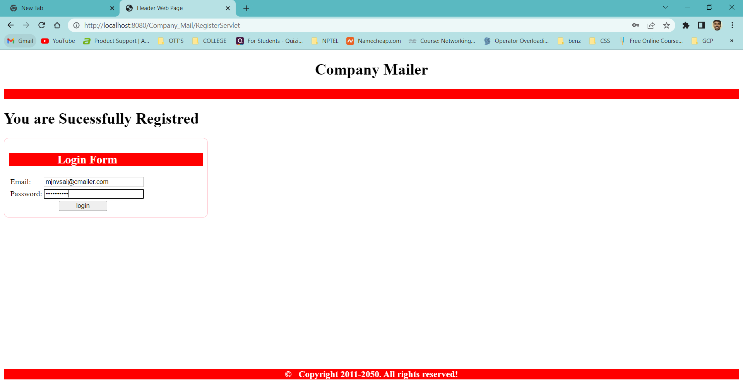

**Compose Mail :**

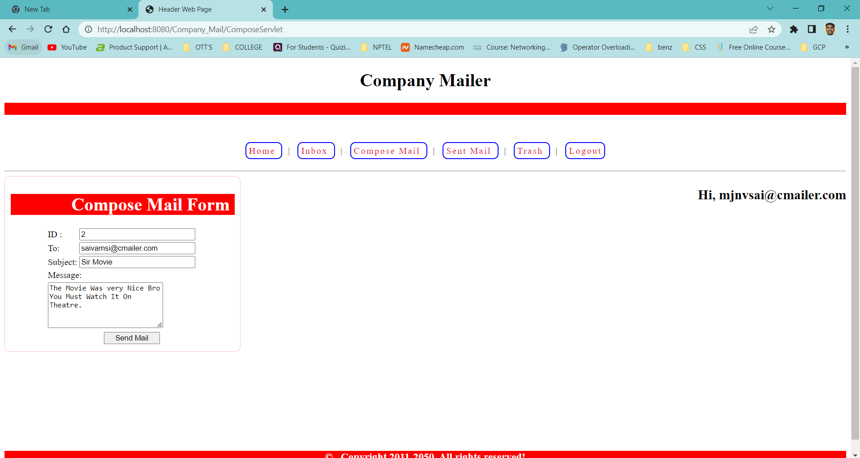

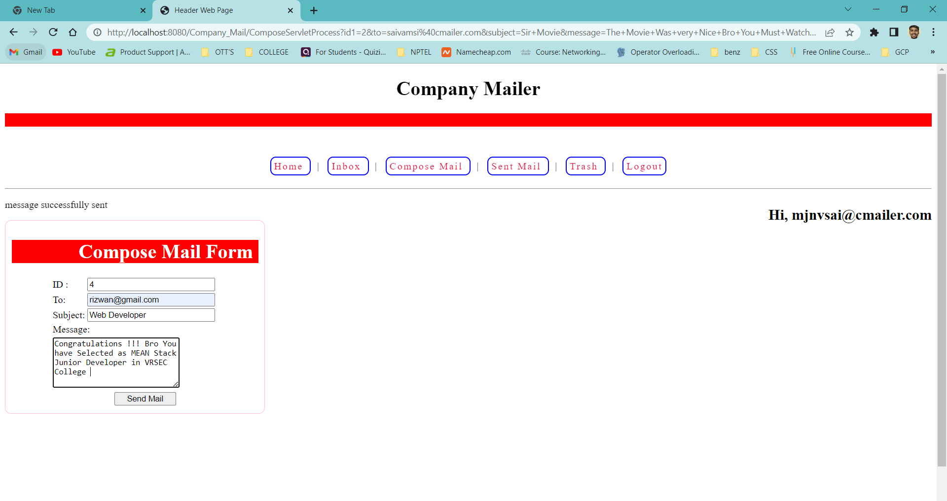

**INBOX :**

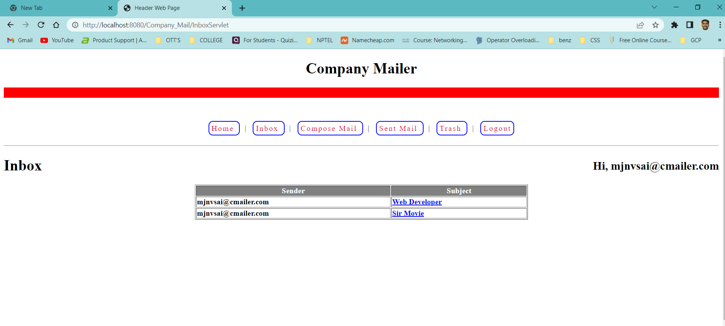

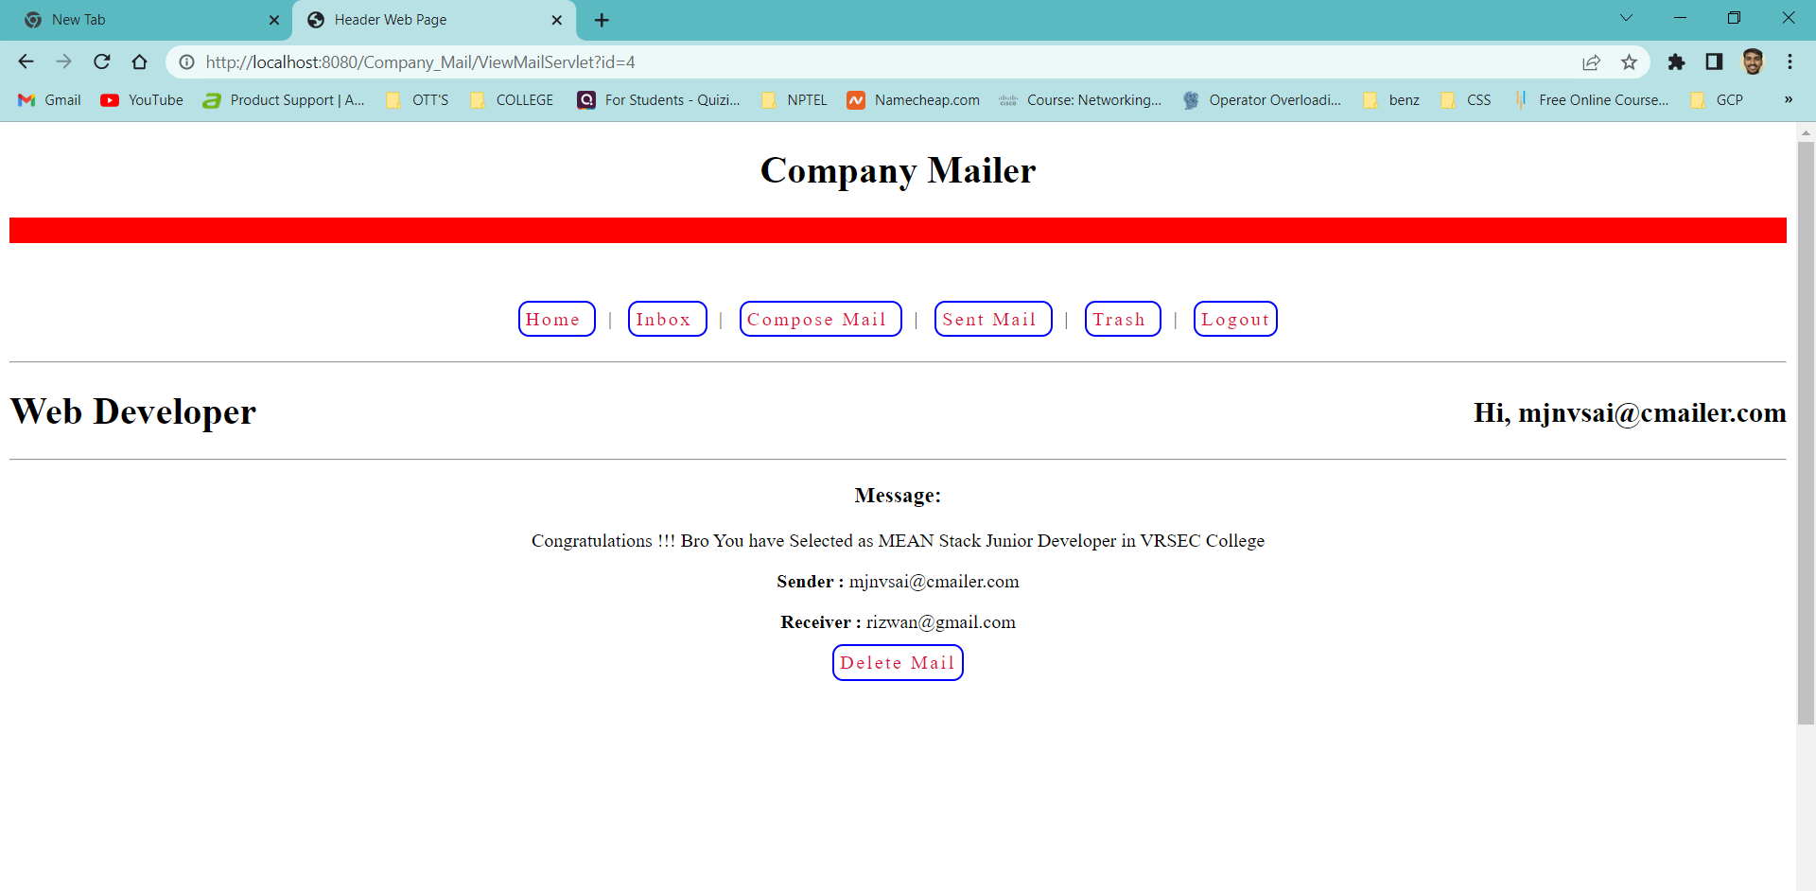

**Delete Mail :**

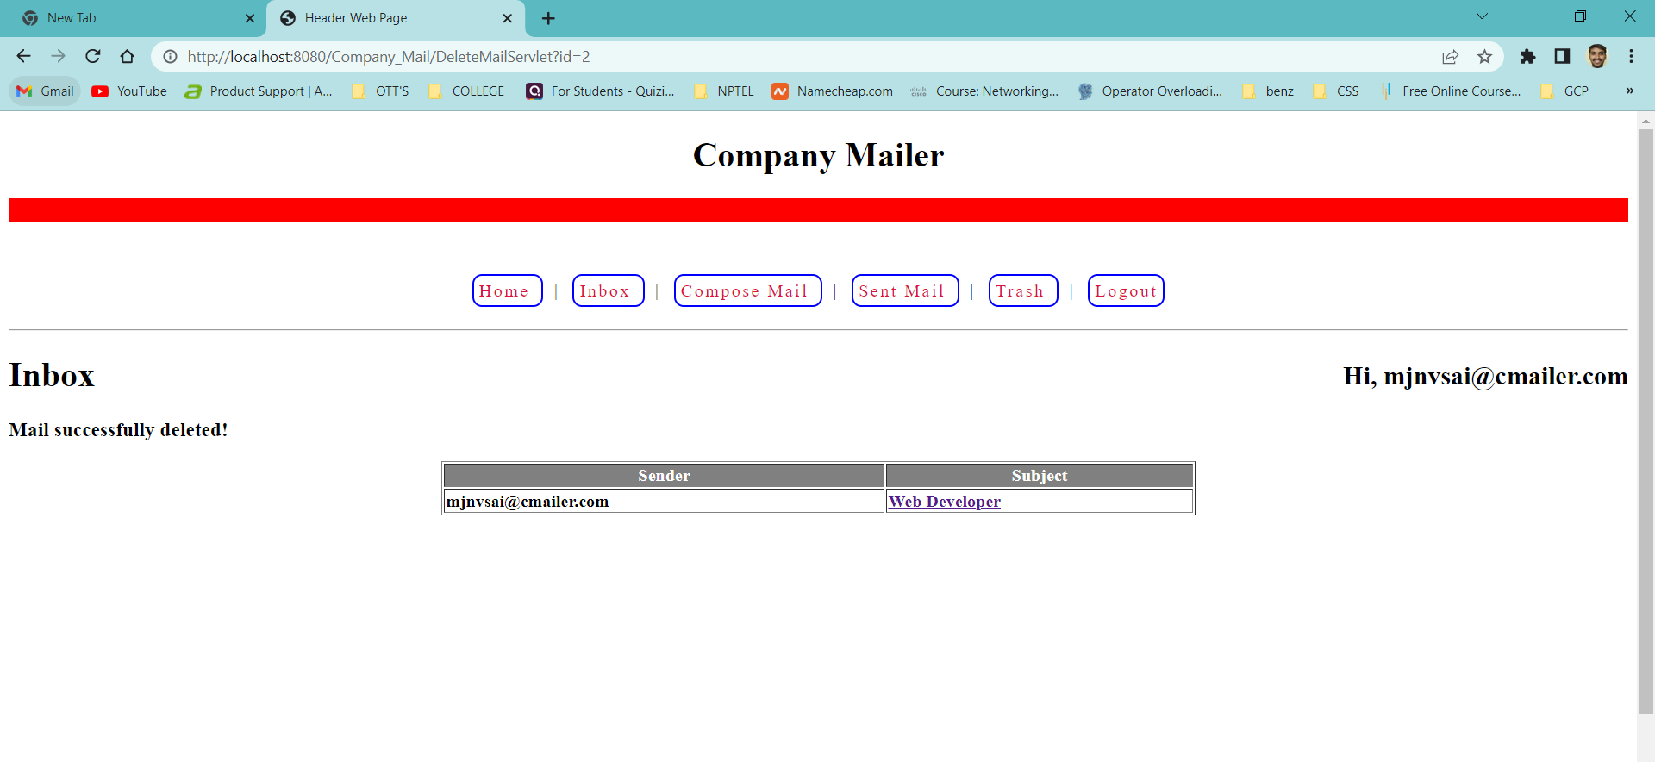

**Sent Mail :**

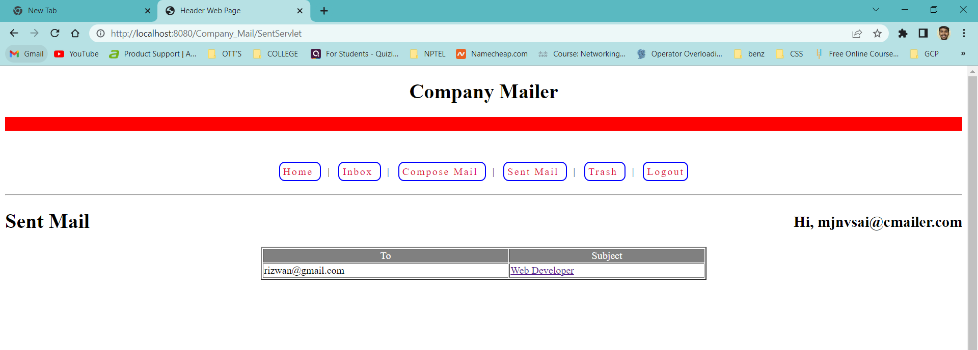

**Trash Mail :**

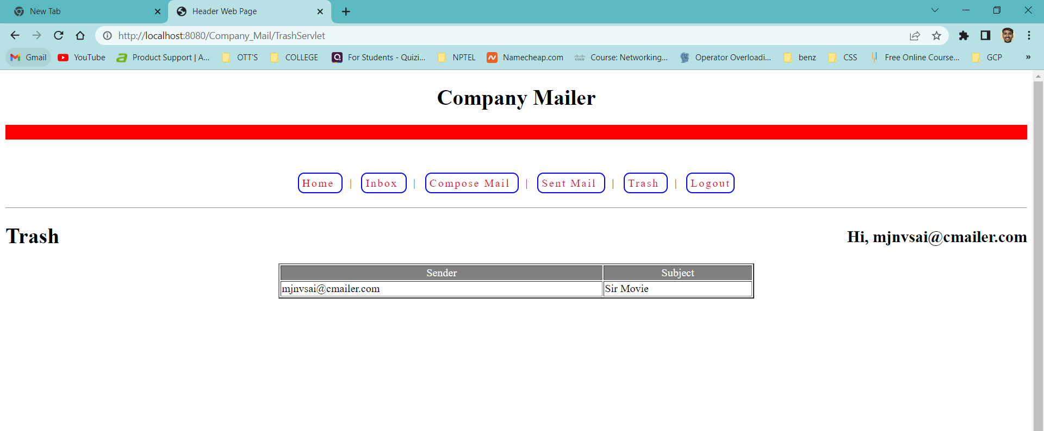

**Logout :**

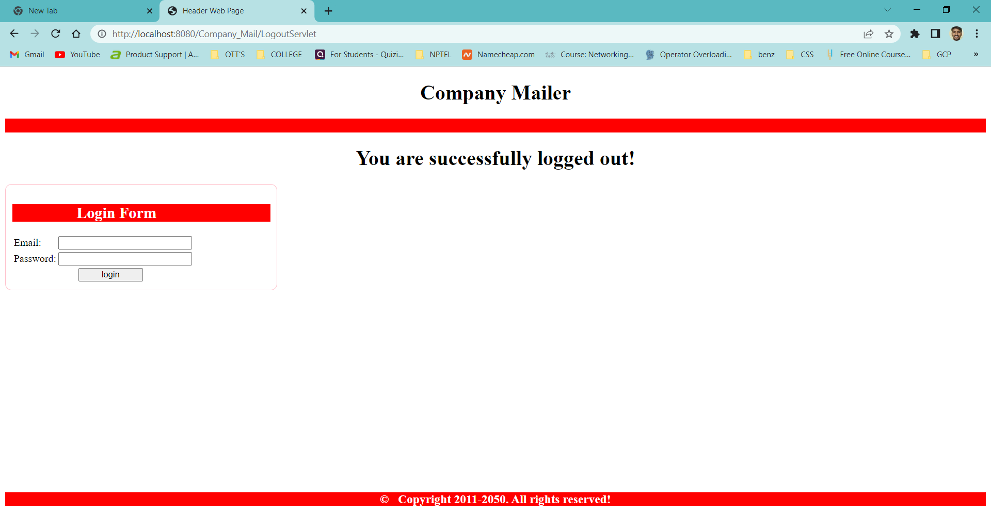

**Result :** Sucessfully Executed The Program.